GRADE: 5: Question 1

Is What We Have Learned About Columbus True?

Student Name_____________________
Date______________________________

Part I: This part consists of a short answer question based on the new Regents Format. On this part, you will be provided with one version of the test based on your readiness to handle critical thinking challenges.

Document Based Question

Directions: The task below is based on documents 1 through 5-6. The task is designed to test your ability to work with documents. Examine each document and answer all questions beneath the document. Use the answers to the questions to help write your essay.

Background: There is recently a controversy of Christopher Columbus and the American National Holiday that honors his contributions to the start of our country. Below you will find two documents with differing perspectives on Columbus and the “the discovery of America” Use your historical skills to connect these documents and to determine the credibility of the history that you have learned in this unit

T

his Short Answer Essay question is based on the accompanying documents and is designed to test your ability to work with historical documents. Each Short Answer Essay Question set will consist of two documents. These documents have been edited for the purposes of the question. Keep in mind that the languages and images used in the document may have been edited for the purposes of the question.

Task: Read and analyze the following documents, applying your knowledge of social studies and skills to write an essay of two or three paragraphs in which you:

- Describe the historical context surrounding the documents by explaining how the two documents are related.
(Hint: Different Perspectives, Cause and Effect or Similarity or Difference)
- Analyze Document 2 and explain the source, audience, and purpose of the document. Based on your analysis, is this document credible?

Describe means to” illustrate something in words or tell about it.”

Different Perspective means to have to different points of view on the same event

Cause means “something that gives rise to something else, the rise of an idea, or brings about a development”

Effect refers to “what happens as a consequence (result, impact, outcome) of an event, an idea, or a development”

Similarity tells how “something is alike or the same as something else”

Difference tells “something is not alike or not the same as something else”

Historical Context refers to the historical circumstances surrounding or connecting the events, ideas, or developments in the documents

Analyze means to “examine a document and determine its elements and relationships”

Document 1

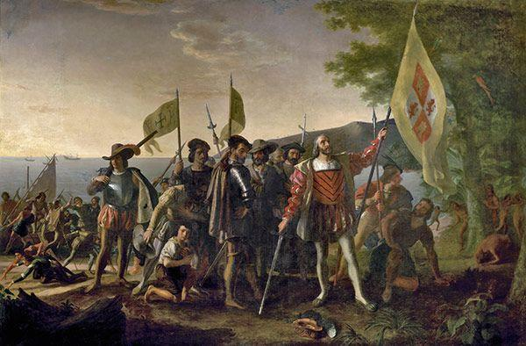

THE LANDING OF COLUMBUS
Painting by John Vanderlyn

This painting depicts Christopher Columbus and members of his crew on a beach in the West Indies, newly landed from his flagship Santa Maria on October 12, 1492.

This painting may be Vanderlyn’s most widely distributed work. In 1869 it appeared on a 15-cent stamp (which, with a brown frame and blue center vignette, was the first bi-color stamp issued by the United States), and in 1893 it was used on a 2-cent stamp among the nation’s first commemorative stamps, the Columbian Exposition Issue. It also appeared on the reverse of a 5-dollar bank note issued in the 1870s.

Document 2

“Those that arrived at these Islands from the remotest parts of Spain, and who pride themselves (as) Christians, steered Two courses principally, in order to Exterminate these Peoples from the face of the Earth… The first involved raising an unjust, bloody, cruel War. The other, by putting them (the natives) to death, (The natives thirsted after their Liberty, or to recover their pristine (clean) Freedom, and shake off the Shackles of so injurious a Captivity.)”

Bartolomé de Las Casas Describes the Exploitation of Indigenous Peoples, 1542

Bartolomé de Las Casas, a Spanish Dominican priest, wrote directly to the King of Spain hoping for new laws to prevent the brutal exploitation of Native Americans. Las Casas’s writings quickly spread around Europe and were used as humanitarian justification for other European nations to challenge Spain’s colonial empire with their own schemes of conquest and colonization.

