\
Does where you live in the Western Hemisphere Determine Your Happiness?
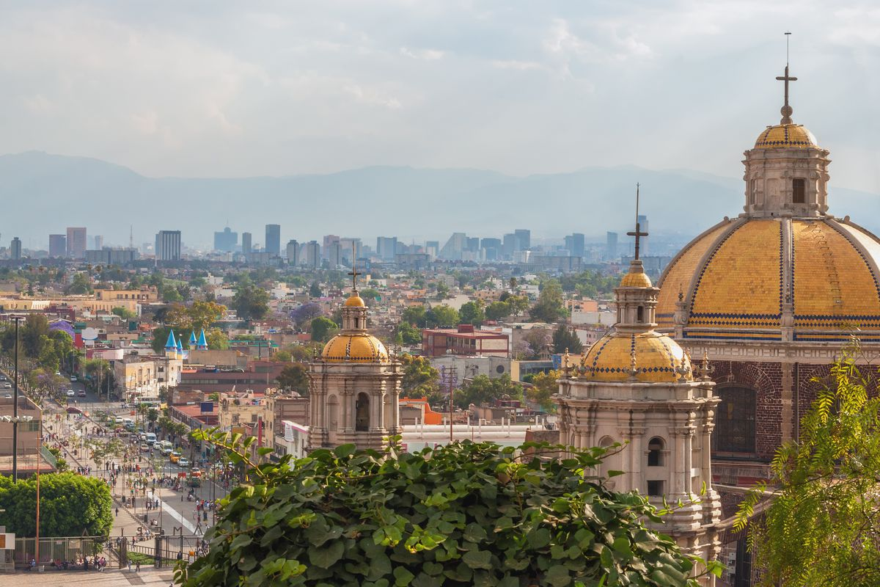
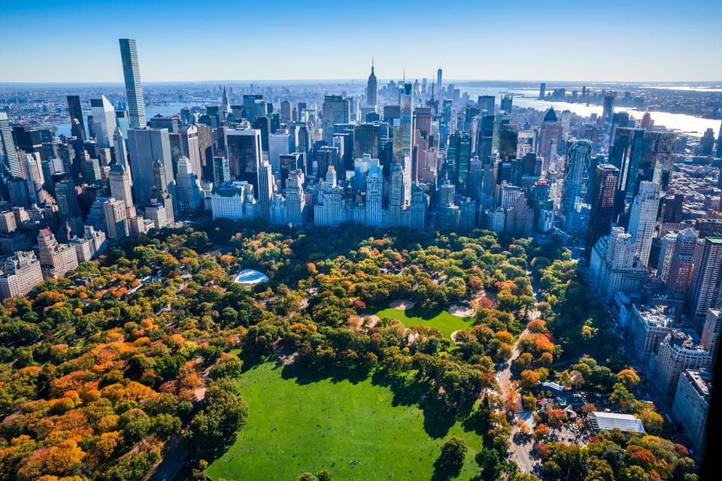
New York City Mexico City

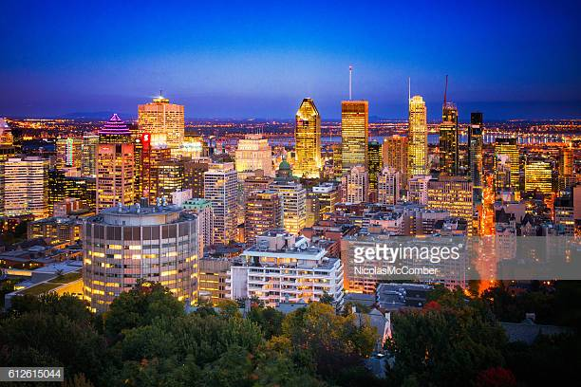
Montreal

Compelling Question:

Does where you live in the Western Hemisphere Determine Your Happiness?

Staging the Question:

Book: The Wise Woman and Her Secret by Eve Marriam and Linda Graves Students will begin the unit by building on the story of a girl who discovers the secret of happiness is acquiring awareness and wonder at what surrounds us. This story leads students to analyze and discover those elements in their own lives that make them happy.

Standards and Practices:
5.4 GEOGRAPHY IN THE WESTERN HEMISPHERE: The diverse geography of the Western Hemisphere has influenced human culture and settlement in distinct ways. Human communities in the Western Hemisphere have modified the physical environment. (Standard: 3, Theme: GEO)

5.4B The Western Hemisphere can be divided into regions. Regions are areas that share common, identifiable characteristics such as physical, political, economic, or cultural features. Regions within the Western Hemisphere include: North America (Canada and the United States), Mesoamerica (Mexico and Central America) Caribbean, South America

- Supporting Question:  - What in your life makes you happy? | Formative Tasks:  After students are presented with the compelling question, What makes you happy? Students will make preliminary decisions on whether or not certain aspects of life make them happy. After being presented with the story The Wise Woman and Her Secret and discussing happiness based on gratitude, students will work collaboratively in groups to come up with a list of things in their lives that they are grateful for. Students will use that list to determine what in their lives they are grateful for and what makes them happy, listing at least ideas of what they are grateful for. | Sources:  - Merriam, E.(1991). The Wise Woman and Her Secret. For Kids. New York.  - Weedmark, David. “Twenty Surprising Facts About Happiness.” The Pursuit of Authenticity,  www.davidweedmark.com/facts  -about-happiness/.

2. Supporting Question:  - How does the geography of Montreal and New York City affect happiness in those cities? | Formative Tasks:  After learning about the five themes of geography and taking a Google Bus Tour of Montreal and New York City, students will complete a Venn diagram based on the similarity and differences between the two geographic locations. Students will use the Venn diagram to determine which city is happier and why, with at least three relevant details. | Sources:  - Teacher Made Google Earth Tour  - Venn Diagram of Montreal and New York City  - U.S. News, (2018) Best things to do in montreal, Retrieved from:  https://travel.usnews.com/montr  eal_canada/things_to_do/  - Teacher Made: Boarding Pass

3. Supporting Question:  - How does the geography of Mexico City affect happiness in that city? | Formative Tasks:  After students take a virtual plane and bus ride to Mexico City while writing a travel journal, the students will complete a Venn Diagram comparing Montreal and New York City to Mexico city. Students will have at least three similarities and three differences between the three cities for mastery. | Sources:  Cocking, L. (2016, November 27). The Best Things To See & Do In Oaxaca City. Retrieved April 02, 2018, from https://theculturetrip.com/north-america/mexico/articles/the-best-things-to-see-do-in-oaxaca-city/  S., Dauksis, A., Osorno, A., F., B., & Wrona, L. (2014, March 21). Mexico. Retrieved April 02, 2018, from https://kids.nationalgeographic.com/explore/countries/mexico/#Mexico-Map-cut.jpg  The Teacher’s Passport (n.d.) Travel Bundle (Passports, Boarding Passes, Travel Journals). Teachers Pay Teachers. Retrieved from https://www.teacherspayteachers.com/Product/Travel-Bundle-Passports-Boarding-Passes-Travel-Journals-1997983

4. Supporting Question:  - What were the major historical events that shaped modern-day Mexico City , Montreal, and New York? | Formative Tasks:  After a brief PowerPoint on the history of contemporary Montreal, New York City, and Mexico, students will take their knowledge and apply it in a statement strategy by splitting into 4 groups and reading individual documents on the Mexican War for Independence, the Declaration of Independence, and the French and Indian War in order to build their knowledge of the topic, scoring at least a 9 out 12 on a teacher created rubric | Sources:  - A Google Slides presentation (Super Mario Bros past and present, and contemporary Mexico, Montreal, and New York.  - Documents: Teacher made overviews of the British Defeat the French in Canada, The Declaration of Independence, and Grito de Dolores. (Sources are in the lesson plan with the actual documents.)

5. Supporting Question:  - What wourld it have felt like to experience the major historical event that shaped modern-day Mexico, Montreal, and New York? | Formative Tasks:  After reviewing documents about the three events in a statement strategy exercise, students will present information to diverse audiences by performing an Act It Out Statue exercise and writing a museum statue caption based on the historical documents given. Students will score at least a 2/3 based on the History Alive Rubric and a 4/5 based on the teacher created Museum Caption Checklist. | Sources:  - Google Slides presentation (Statue Scene - History Alive!)  - Documents: The British Defeat the French, The Declaration of Independence, and Grito de Dolores.  - Props/costumes  - Bower, B., & Lobdell, J. (2005). Bring Social Studies Alive!: The TCI Approach for Elementary  School Social Studies. Ingram

6. Supporting Question:  - How do we know what we have learned about Mexico, United States, and Montreal is true? | Formative Tasks:  After analyzing four primary source documents and participating in a group discussion, students will write arguments to support a claim and engage in a group discussion using the SCIM-C method to determine if what we have learned so far about Mexico, United States, and Montreal is valid. Students will conclude by writing a paragraph stating if the history we learned about yesterday is true or not using at least three facts from the document they analyze. | Sources:  - A Google Slides Presentation (SCIM-C Method, Thinking like a Historian)  - Documents (Sources are Cited on Each Document--Montreal, United States, and Mexico)

7. Supporting Question:  - Can We Make an Opinion Based on Evidence? | Formative Tasks:  After learning how to determine if evidence is credible, students will evaluate the credibility of the reasoning and the relevance and sufficiency of evidence through a history mystery. Students will determine which city is the happiest between Mexico City, Montreal and New York City by using valid reasoning and relevant and sufficient evidence. Students must include at least 3 pieces of relevant and sufficient evidence from the history mystery to support their answer. Students will be graded based on a teacher designed checklist and must obtain a score of 3/4. | Sources:  - Teacher Made History Mystery  Document sources are on each  document  - Supporting Claims sheet  - Pink Panther Theme Song https://www.youtube.com/watch?v=9OPc7MRm4Y8

8. Supporting Question:  - How can we effectively express what we believe in writing? | Formative Tasks:  After engaging in a practice Google Slides pre-writing exercise on the game Fortnite using TDFC, students will provide logically ordered reasons that are supported by facts and details from various sources by completing a TDFC on their required DBQ on geography and happiness. Students will do this with 80% accuracy. | Sources:  - Source A: Teacher Made Google slides presentation (Fortnite practice essay)  - Source B: Teacher Made TDFC Graphic Organizer  - Source C: Teacher Made TDFC Planning Sheet for a Document Based Question

Summative Performance Task | Argument | Students will complete a DBQ essay answering the unit’s compelling question: Does where you live in the Western Hemisphere determine your happiness?
 | Extension | Students unable to write the essay will answer the compelling question by creating a poster with their top three documents cut out and pasted to graphic organizer. Students will then compose a Flipgrid recording explaining their choices and making their cases.

Taking Informed Action:
Students will create a flipgrid intorducing themselves to students in both Mexico City and Montreal. They will share pictures and a story about why living in New York makes them happy. In response, the students in Mexico City and Montreal will share the sources of what makes them happier. Students will engage in a hemispheric Skype (Google Hangout) session on their views on the compelling of question.

