5th Grade
Canada Unit
By: Marissa Croce, Laura Drew, Marina Foley, Annie Jablonski, Victoria Palazzo, Alexandra Rinck, Katherine Scandiffio

This fifth grade Inquiry Design Model (IDM) curriculum allows students to explore the meaning of happiness and its relation to a person’s location in the world. Students will undertake the compelling question, “Does where you live in the Western Hemisphere determine your happiness?”

Compelling Question:
Does where you live in the Western Hemisphere determine your happiness?

Standards and Practices:
5.4 GEOGRAPHY IN THE WESTERN HEMISPHERE: The diverse geography of the Western Hemisphere has influenced human culture and settlement in distinct ways. Human communities in the Western Hemisphere have modified the physical environment. (Standard: 3, Theme: GEO)
5.4c The physical environment influences human population distribution, land use, and other forms of economic
activity.
5.5 COMPARATIVE CULTURES: The countries of the Western Hemisphere are diverse and the cultures of these countries are rich and varied. Due to their proximity to each other, the countries of the Western Hemisphere share some of the same concerns and issues. (Standards: 1, 2; Themes: ID, MOV, SOC)
5.5a The countries of the Western Hemisphere have varied characteristics and contributions that distinguish them from other countries.
5.5b. Countries in the Western Hemisphere face a variety of concerns and issues specific to the region.

Staging the Question:
“How Full is Your Bucket for kids” by Tom Rath and Mary Reckmeyer

1. Supporting Question:  What determines happiness? | Formative Task:  The teacher will frame the question: Does where you live in the Western Hemisphere determine your happiness? In order to do this, the students and teacher will participate in a discussion about happiness after reading the book “How Full is Your Bucket for Kids.” The teacher will discuss how there are many kinds happiness that people can experience.After our discussion, students will write a letter of gratitude to someone in their life who has had an impact on them, attaining a score of a two out of four. | Sources:  Source A: “How Full is Your Bucket for Kids” by Tom Rath and Mary Reckmeyer  Source B: Happiness Presentation  Source C: Worksheets (“How Full is Your Bucket for kids”, Gratitude Instructions, Homework Instructions)

2. Supporting Question:  How does the geography of life in Canada affect life there? | Formative Task:  Students will be taken on a plane ride and bus tour of different cities, attractions, and natural landmarks in Canada. After the tour, students will write a postcard to a friend or family member back in New York. To achieve mastery, students will write at least three sentences about a place they saw or visited and at least three more sentences about how what they saw resembles home or not. | Sources:  Source A: Google Slides tour presentation  Source B: Tour pamphlet to take notes  Source C: Postcard to send home

3. Supporting Question:  How did Canada come to be Canada? What historical events have shaped the country? | Formative Task:  Students will complete a read and retell activity with a partner on one of three historical events which shaped Canada today. After, each of the three groups will use the information provided in the documents to go into a “Time Machine” and complete and Act It Out skit with at least three relevant facts from the document. | Sources:  Source A: Time Machine Powerpoint Presentation  Source B: Read and Retell Documents on The Northwest Passage, French Exploration, and Loss to the British

4. Supporting Question:  How do we know what we have learned about Canada is true? | Formative Task:  After examining four documents and engaging in historical thinking using the SCIM-C method, students will discuss and make a claim about if the sources presented that depict life in Canada are valid. Students will conclude by writing a response on an exit ticket worksheet that encompasses an overview of how thinking like a historian has shaped their view on life in Canada including at least three references to documents analyzed in class. | Sources:  Source A:  Thinking Like a Historian PowerPoint Presentation  Source B:  Four Primary Source Documents to complete SCIM-C  Source C:  Exit Ticket - IS THIS VALID?

5. Supporting Question:  Are Canadians happier than Americans? Evaluate the credibility of the sources | Formative Task:  After completing a history mystery, students will create a clam on which country they think is happier, Canada or America. Students will evaluate the credibility of the sources provided. | Sources:  Source A: History Mystery packets with included articles  Source B: Powerpoint Presentation  Source C: Supporting Claim Handout

6. Supporting Question:  What can we do to connect with Canada to improve our understanding? | Formative Task:  After watching a short video on Nunavik, students will engage effectively in a range of collaborative discussions with diverse partners on building on others’ ideas and expressing their own clearly and creating a plan for taking informed action to aid students in Nunavik. Student’s efforts will be evaluated the “I CAN Make a Difference” exit ticket successfully answering at least 2/3 questions. | Sources:  Source A: Informed Action Powerpoint  Source B: Skype with students in Nunavik Canada  Source C: The Global Goals model

7. Supporting Question:  Can we express what we have learned in writing? | Formative Task:  Students will participate in a Meeting of the Minds activity where they will work together to determine if their countries can work together to create world peace, human rights, prosperity and understanding in the future. Students will independently write an essay, responding to the overarching question of the unit: Does where you live in the hemisphere determine your happiness? | Sources:  Source A: Powerpoint Presentation  Source B: Reading material for groups on Mexico, Puerto Rico, and Canada.  Source C: Meeting of the Minds Packet

Summative Performance Task

Argument: Students will write a DBQ essay answering the question: Does where you live in the Western Hemisphere determine your happiness?

Extension: Students will create an iMovie video expressing how where you live can determine a person’s happiness.

Taking Informed Action: What can we do to connect with Canada to improve our understanding?
- Students will skype with a fifth grade class from Canada, discussing and sharing how their lives are similar and different.
- Students will create signs with informative information on Nunavik regarding a bake sale, to help raise money for Nunavik.
- Students will organize a supply/book drive to gather resources to send to help enrich school life in Nunavik.
- Students will create and informative video to educate the rest of the school on life in Nunavik Canada . .

GRADE 5 DBQ

Are people in Canada happier than people in America?

Student Name________________________
Date___________________________

Part III: This part consists of a document-based question. On this part, you will be provided with one version of the test based on your readiness to handle critical thinking challenges. (You may opt for a more difficult version than your teacher provides, but you will be graded on the version that you complete)

Document Based Question

Directions: The task below is based on documents one through six. The task is designed to test your ability to work with documents. Examine each document and answer all of the questions beneath each document. Use the answers to the questions to help write your essay.

Background
There are many contributing factors that may or may not affect the happiness of the people living within those regions. Although Canada and America border each other, there are vast differences between these two countries. One major factor that stands out is the overall happiness of each countries’ people.

Task: Use the information from the documents and your knowledge of social studies; write an essay in which you:

- Discuss two factors according to psychological research that are believed to make people happy.
- Discuss life in the two regions, Canada and America.
- Evaluate which region you believe is happiest and why.

In your essay remember to
- Write an opinion essay, arguing how overall happiness affects life in the different countries. Make a claim as to whether Canada or America is happier using evidence from the documents.
- Include an introduction, a body, and a conclusion.
- Use information from at least three documents in your answer.
- Include facts, relevant details, and reason in developing your ideas.

Document #1:
The Happy Planet Index (HPI) measures what matters: sustainable wellbeing for all. It tells us how well nations are doing at achieving long, happy, sustainable lives.
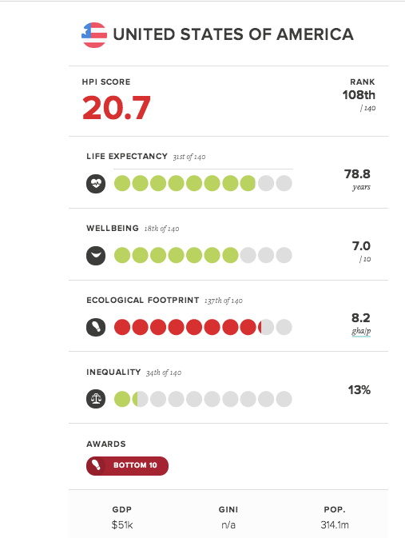
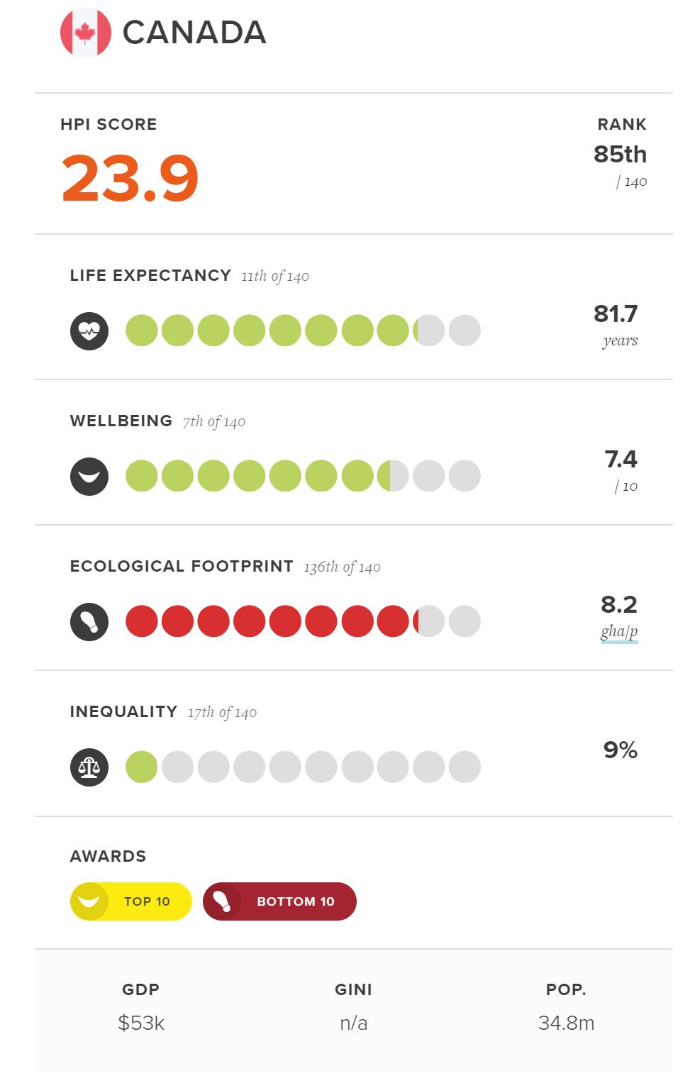
- Referring to the chart, which country is happier? ________________________________________________________________ [1]

2. According to the chart, name one major contributing factor towards overall happiness? Why do you feel that it is an important factor?
________________________________________________________________________________________________________________________________________________________________________________________________________________[2]

3. Does this chart mean that everyone in Canada is happier than everyone in America?
_________________________________________________________________[1]

Document #2:

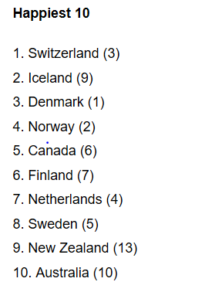
All of the happiest countries are rich, although only three of the Top 10 overlap with the 10 wealthiest countries based on gross domestic product per capita-Switzerland, Norway and Australia. The idea behind the report is that well-being is determined by more than just wealth, and that improving life satisfaction or happiness ought to be a consideration in public policymaking.
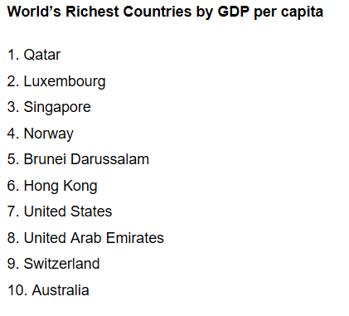

1. What do the lists tell you about the United States?
___________________________________________________________________ [1]

2. Do you think someone would be happier in the Canada or the United States?
________________________________________________________________________________________________________________________________________________________________________________________________________________[2]

Document #3:
“What's your definition of happiness? Research in the field of positive psychology and happiness often define a happy person as someone who experiences frequent positive emotions, such as joy, interest, and pride… although the phrase a "happy person" is probably incorrect because it assumes that they are naturally happy or that positive things happen to them more often. Nobody is immune to life's stressors, but the question is whether you see those stressors as moments of opposition or moments of opportunity.”

- According to the document, what are two contributing factors towards an individual’s happiness?
__________________________________________________________________________________________________________________________________________[1]

- Is there such thing as a “happy person?” What makes you a “happy person?”
________________________________________________________________________________________________________________________________________________________________________________________________________________[2]

3. How do you view life’s stressors, as an opportunity or as an obstacle?
__________________________________________________________________________________________________________________________________________[1]

Document #4:

Weather in Florida, USA is warm all year round.

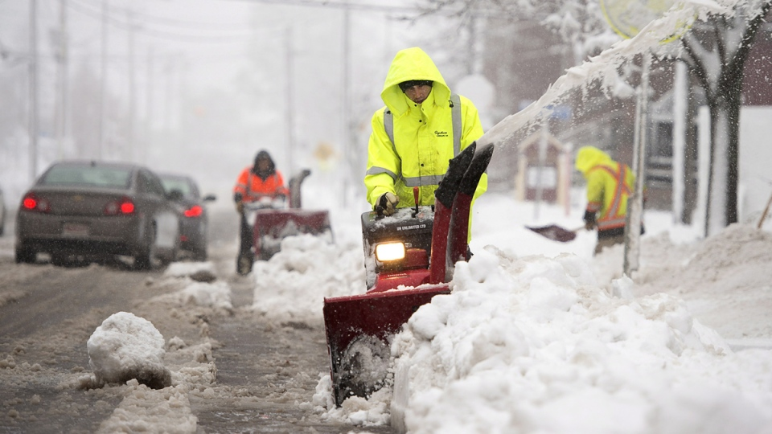
Canada endures a long, harsh, and bitterly cold winter season.

- Based off of the pictures, do you think people in Canada are happier than people in America? Why?
________________________________________________________________________________________________________________________________________________________________________________________________________________[2]
Document #5:

Each country has a population of indigenous people. This means those people and their culture originated from and is native to that particular country. For example, Native Americans are the indigenous people of the United States of America.

Indigenous v. Non-indigenous Populations in Canada:
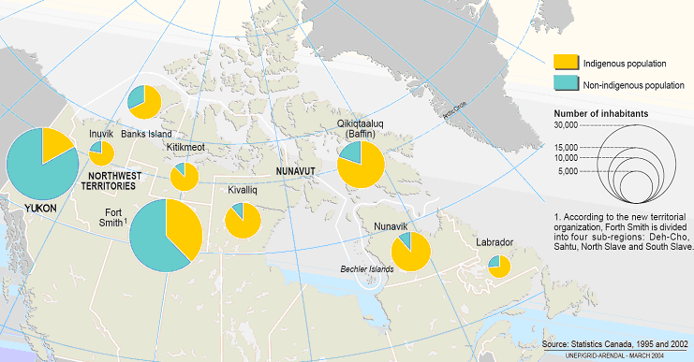

- What does it mean to be indigenous? Do you think being indigenous to an area makes you more or less happy?
__________________________________________________________________________________________________________________________________________________________________________________________________________[2]

- According to the map, which area in Canada has the highest and lowest population of indigenous people?
______________________________________________________________________________________________________________________________________[1]

Document #6:
In life, we all experience different scenarios that has an impact on our lives. Through the eyes of Felix, we discover that everyone has an invisible bucket and how we feel when our bucket is full or empty. For example, when Felix is being teased for the backpack he has, his bucket becomes a little emptier but when he receives a good grade on his test, his bucket becomes a little fuller again. Throughout the book, we are able to see how your everyday interactions can either fill or empty that invisible bucket and the impact it can have on yourself and others around you. For example, after Felix’s bucket was almost full, he decided to help a help a student retrieve his baseball and helped a man pick up his papers. But once he did these actions, he noticed his bucket was getting filled more.

- Based on the document above, what were some ways that Felix filled his invisible bucket?
__________________________________________________________________________________________________________________________________________[1]

2. After helping people with certain tasks throughout the day, why was Felix’s invisible bucket still being filled?
__________________________________________________________________________________________________________________________________________[1]

3. Based on this definition of happiness, why do you believe helping people makes us happier than gaining a material possession? Does this truly make you happy?
__________________________________________________________________________________________________________________________________________[2]
