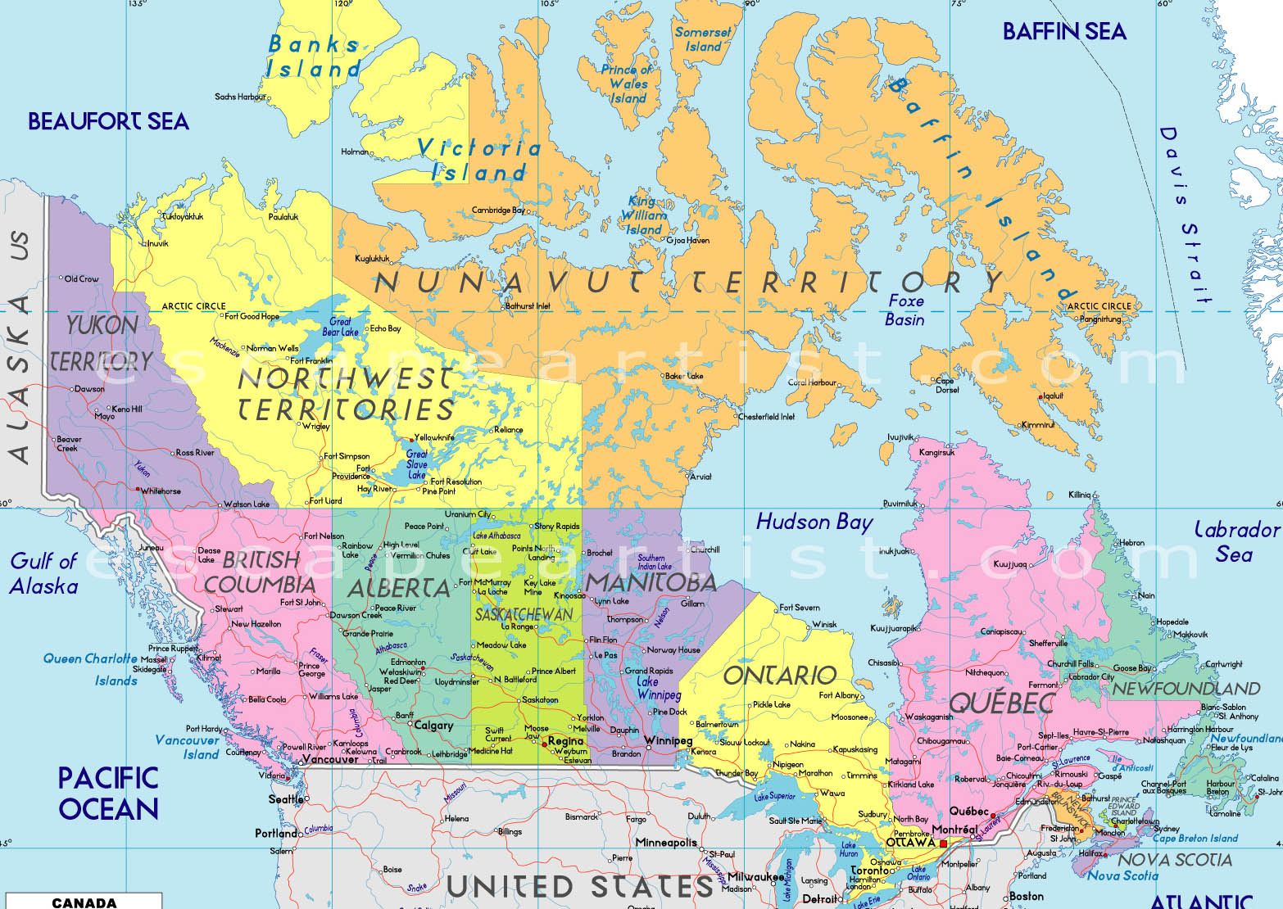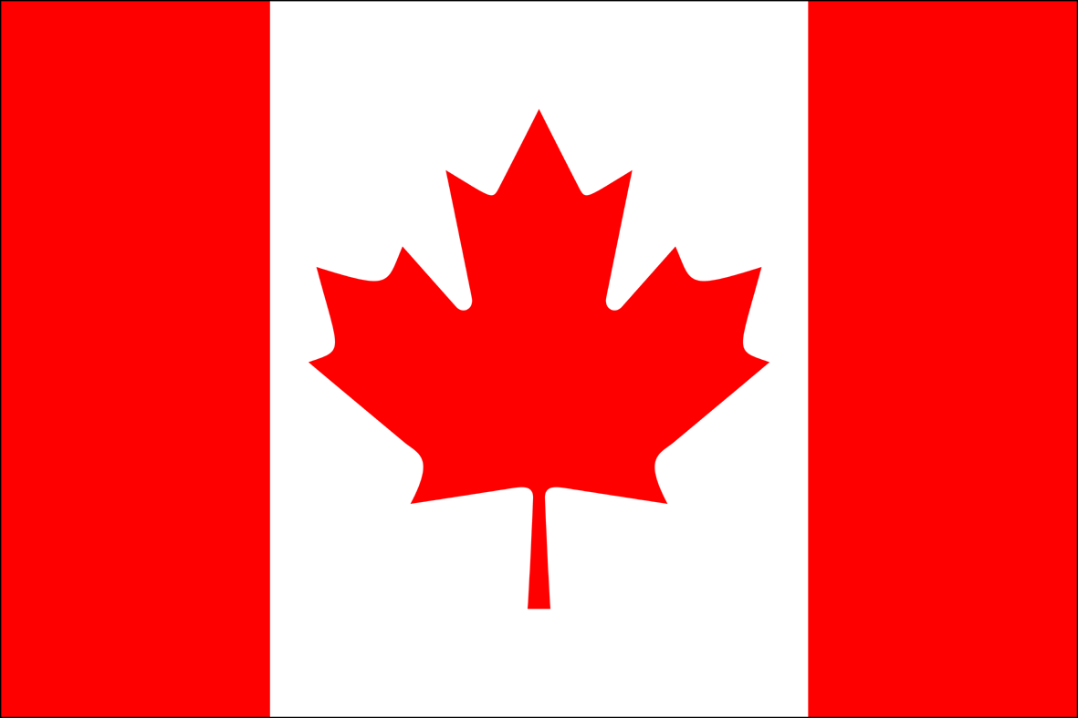

* Canada officially got its own national flag on February 15th, 1965-almost 100 years after it became a country in 1867.
* The capital of Canada is Ottawa.
* Canada is the second largest country in the world by total area.
* Canada shares the longest land boarder with the United Sates.
* The two main languages spoken in Canada are English and French

Let’s take a Trip through Canada!

Use this pamphlet to guide you through our trip! Write down important things you may want to remember and put in your postcard to send back home!

Canada is north of__________________ ___________________.

Canada extends from the ______________ to the ____________ and northward into the ________________.

Canada is broken up into _____ provinces and _____ territories.

___________________________________________________________________________________

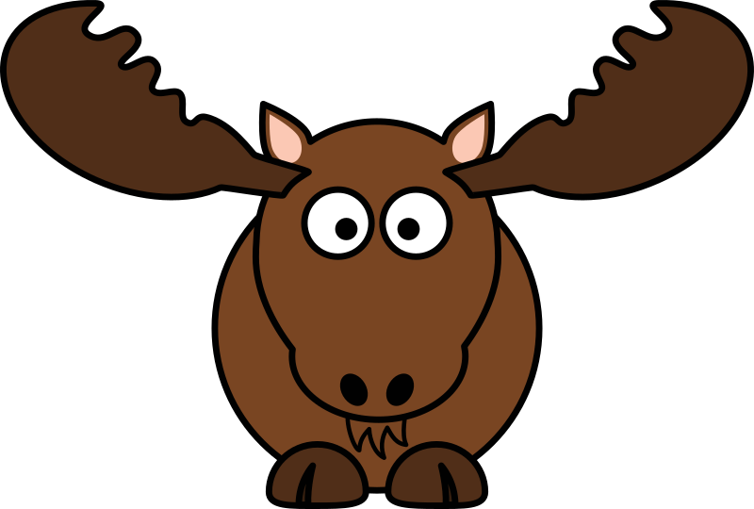

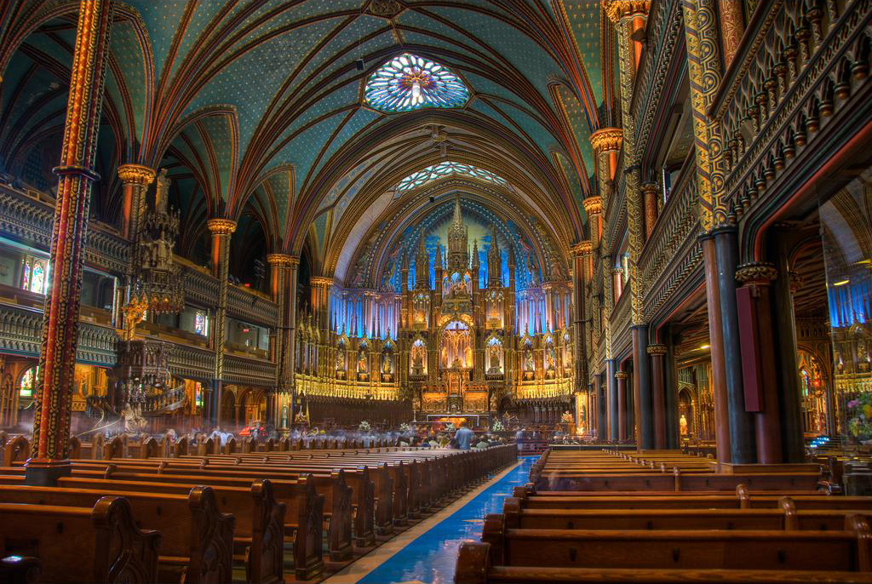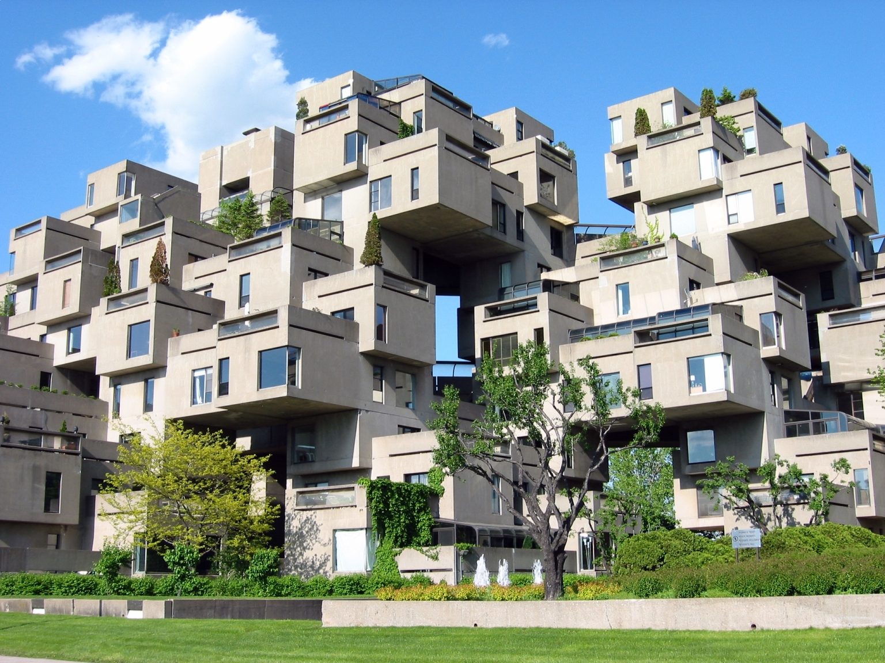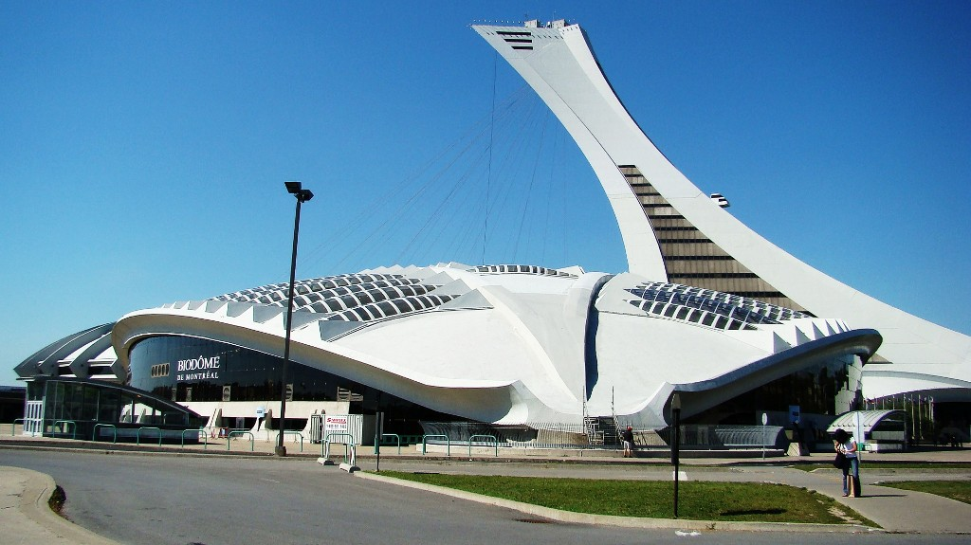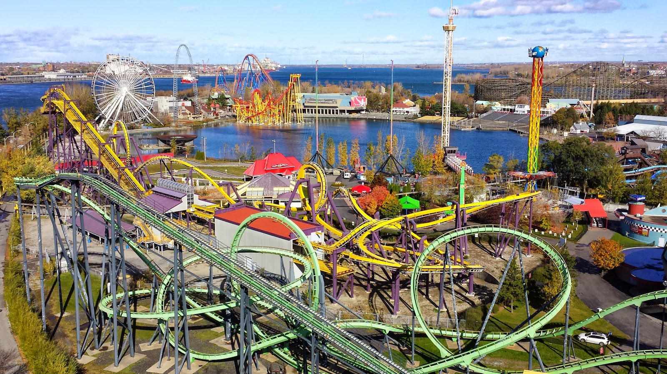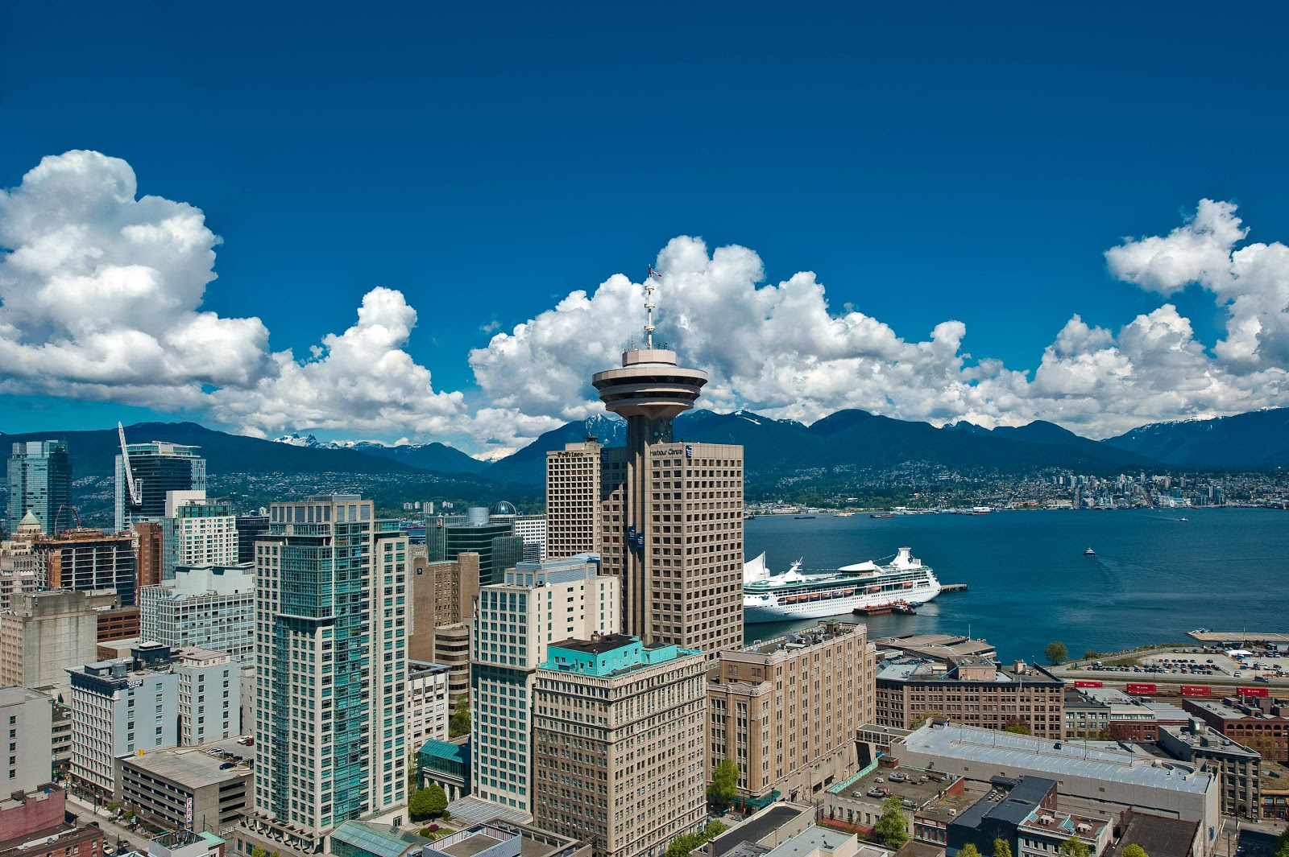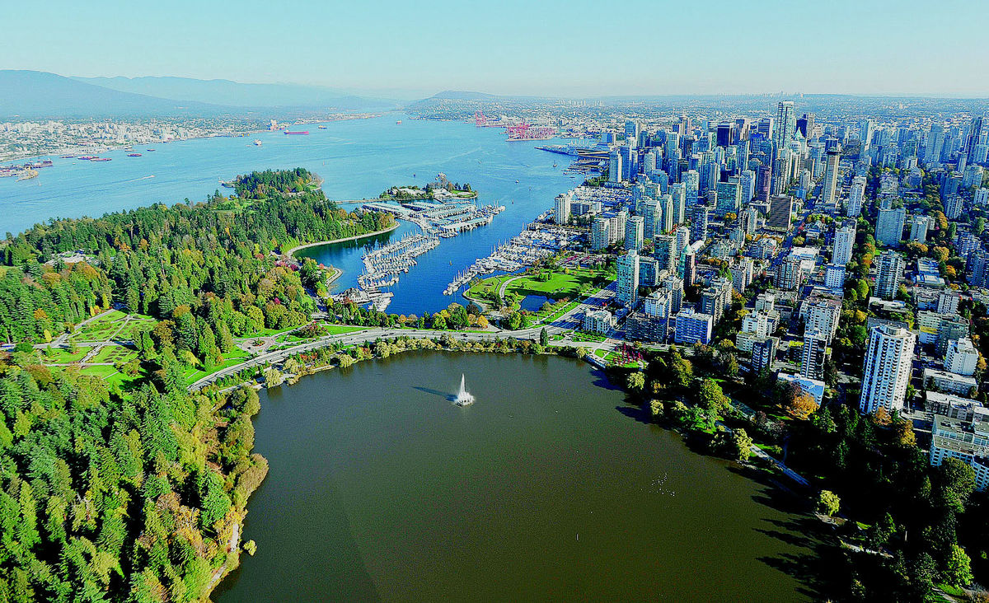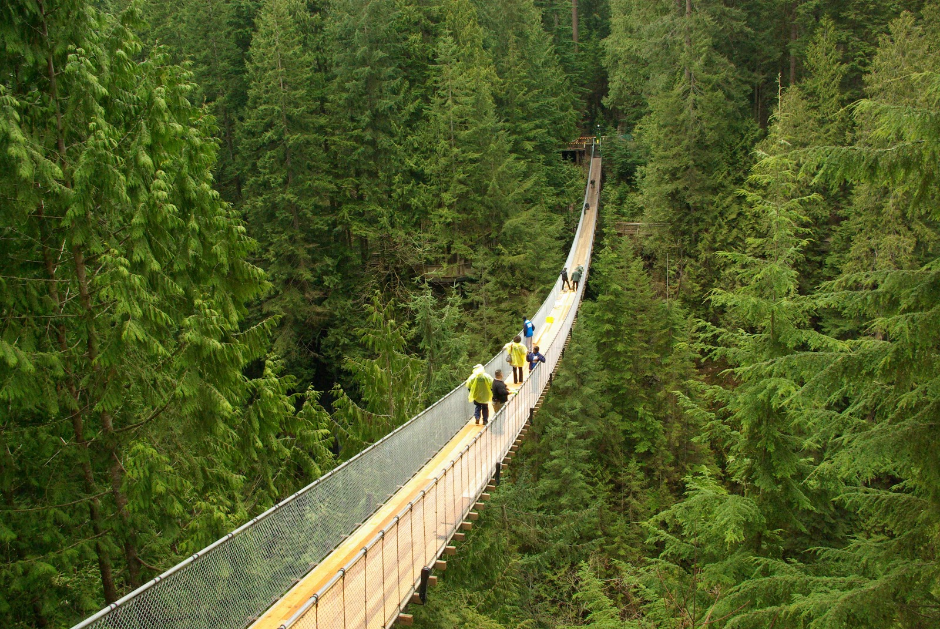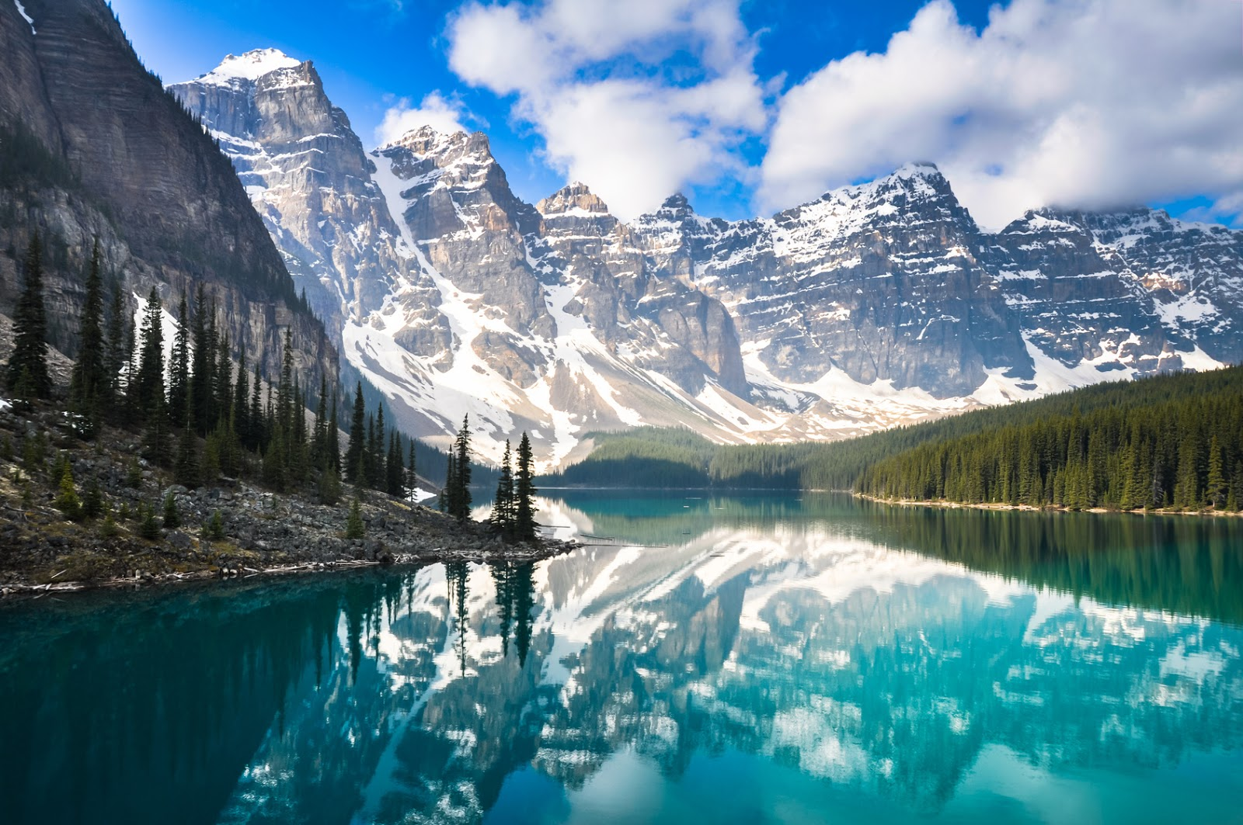

____________________________________________________________________________________________________________

____________________________________________________________________________________________________________

____________________________________________________________________________________________________________

____________________________________________________________________________________________________________

____________________________________________________________________________________________________________

____________________________________________________________________________________________________________

____________________________________________________________________________________________________________

____________________________________________________________________________________________________________

Saskatchewan

_______________________________________________________________________________________________________________________________________