GRADE 5 DBQ

Are people in Canada happier than people in America?

Student Name________________________
Date___________________________

Part III: This part consists of a document-based question. On this part, you will be provided with one version of the test based on your readiness to handle critical thinking challenges. (You may opt for a more difficult version than your teacher provides, but you will be graded on the version that you complete)

Document Based Question

Directions: The task below is based on documents one through six. The task is designed to test your ability to work with documents. Examine each document and answer all of the questions beneath each document. Use the answers to the questions to help write your essay.

Background
There are many contributing factors that may or may not affect the happiness of the people living within those regions. Although Canada and America border each other, there are vast differences between these two countries. One major factor that stands out is the overall happiness of each countries’ people.

Task: Use the information from the documents and your knowledge of social studies; write an essay in which you:

- Discuss two factors according to psychological research that are believed to make people happy.
- Discuss life in the two regions, Canada and America.
- Evaluate which region you believe is happiest and why.

In your essay remember to
- Write an opinion essay, arguing how overall happiness affects life in the different countries. Make a claim as to whether Canada or America is happier using evidence from the documents.
- Include an introduction, a body, and a conclusion.
- Use information from at least three documents in your answer.
- Include facts, relevant details, and reason in developing your ideas.

Document #1:
The Happy Planet Index (HPI) measures what matters: sustainable wellbeing for all. It tells us how well nations are doing at achieving long, happy, sustainable lives.
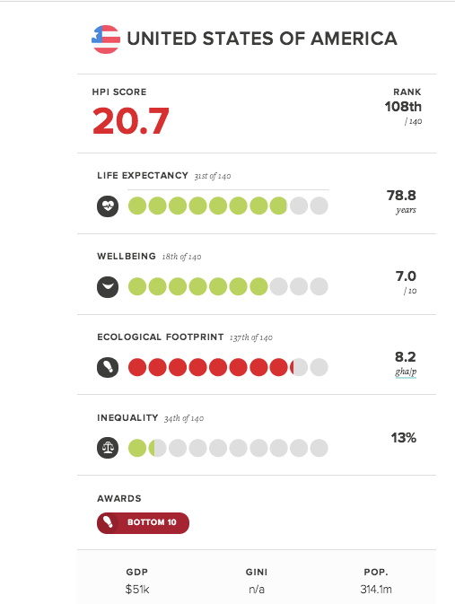
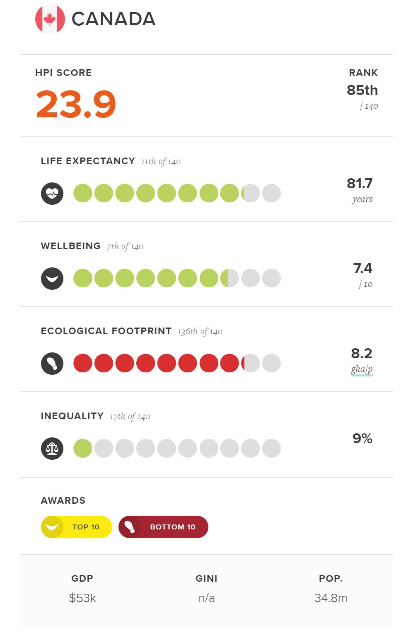
- Referring to the chart, which country is happier? ________________________________________________________________ [1]

2. According to the chart, name one major contributing factor towards overall happiness? Why do you feel that it is an important factor?
________________________________________________________________________________________________________________________________________________________________________________________________________________[2]

3. Does this chart mean that everyone in Canada is happier than everyone in America?
_________________________________________________________________[1]

Document #2:

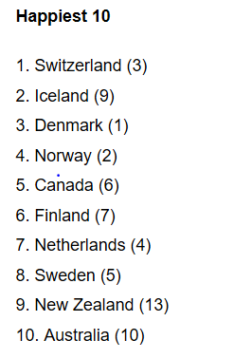
All of the happiest countries are rich, although only three of the Top 10 overlap with the 10 wealthiest countries based on gross domestic product per capita-Switzerland, Norway and Australia. The idea behind the report is that well-being is determined by more than just wealth, and that improving life satisfaction or happiness ought to be a consideration in public policymaking.
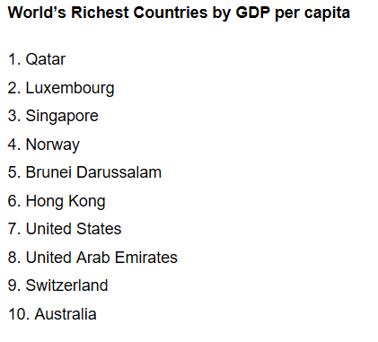

1. What do the lists tell you about the United States?
___________________________________________________________________ [1]

2. Do you think someone would be happier in the Canada or the United States?
________________________________________________________________________________________________________________________________________________________________________________________________________________[2]

Document #3:
“What's your definition of happiness? Research in the field of positive psychology and happiness often define a happy person as someone who experiences frequent positive emotions, such as joy, interest, and pride… although the phrase a "happy person" is probably incorrect because it assumes that they are naturally happy or that positive things happen to them more often. Nobody is immune to life's stressors, but the question is whether you see those stressors as moments of opposition or moments of opportunity.”

- According to the document, what are two contributing factors towards an individual’s happiness?
__________________________________________________________________________________________________________________________________________[1]

- Is there such thing as a “happy person?” What makes you a “happy person?”
________________________________________________________________________________________________________________________________________________________________________________________________________________[2]

3. How do you view life’s stressors, as an opportunity or as an obstacle?
__________________________________________________________________________________________________________________________________________[1]

Document #4:

Weather in Florida, USA is warm all year round.

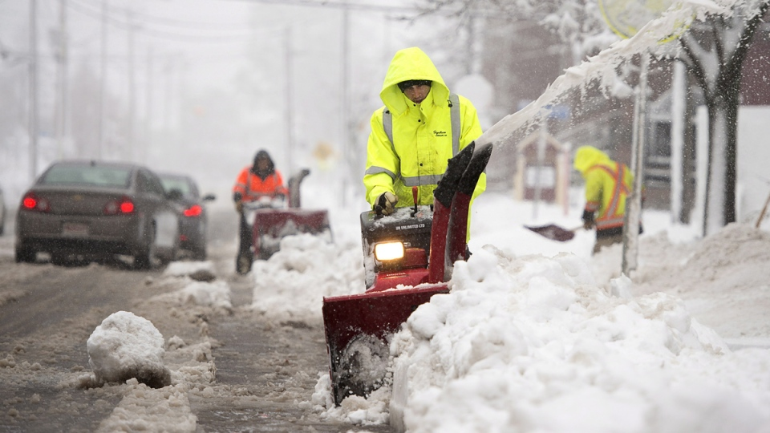
Canada endures a long, harsh, and bitterly cold winter season.

- Based off of the pictures, do you think people in Canada are happier than people in America? Why?
________________________________________________________________________________________________________________________________________________________________________________________________________________[2]
Document #5:

Each country has a population of indigenous people. This means those people and their culture originated from and is native to that particular country. For example, Native Americans are the indigenous people of the United States of America.

Indigenous v. Non-indigenous Populations in Canada:
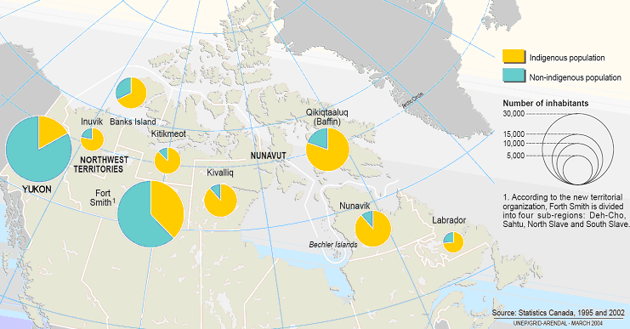

- What does it mean to be indigenous? Do you think being indigenous to an area makes you more or less happy?
__________________________________________________________________________________________________________________________________________________________________________________________________________[2]

- According to the map, which area in Canada has the highest and lowest population of indigenous people?
______________________________________________________________________________________________________________________________________[1]

Document #6:
In life, we all experience different scenarios that has an impact on our lives. Through the eyes of Felix, we discover that everyone has an invisible bucket and how we feel when our bucket is full or empty. For example, when Felix is being teased for the backpack he has, his bucket becomes a little emptier but when he receives a good grade on his test, his bucket becomes a little fuller again. Throughout the book, we are able to see how your everyday interactions can either fill or empty that invisible bucket and the impact it can have on yourself and others around you. For example, after Felix’s bucket was almost full, he decided to help a help a student retrieve his baseball and helped a man pick up his papers. But once he did these actions, he noticed his bucket was getting filled more.

- Based on the document above, what were some ways that Felix filled his invisible bucket?
__________________________________________________________________________________________________________________________________________[1]

2. After helping people with certain tasks throughout the day, why was Felix’s invisible bucket still being filled?
__________________________________________________________________________________________________________________________________________[1]

3. Based on this definition of happiness, why do you believe helping people makes us happier than gaining a material possession? Does this truly make you happy?
__________________________________________________________________________________________________________________________________________[2]
