Molloy College
Division of Education
Annie Jablonski Professor: Dr. Sheehan
EDU 351 01 April 10th, 2018
Grade: 5 Topic: Geography of Canada Social Studies

INSTRUCTIONAL OBJECTIVES
After students take a virtual plane ride and bus tour visiting some of the major cities, attractions and natural landmarks of Canada students will write informative/explanatory text to examine and convey ideas by writing a postcard to be mailed back home to a family member or friend. To achieve mastery students will include at least three accurate sentences about places they went to or saw in Canada and how it is the same or different as living in New York.

NYS-CCLS / +NYS STANDARDS AND INDICATORS

Key Idea:
5.4 GEOGRAPHY IN THE WESTERN HEMISPHERE: The diverse geography of the Western Hemisphere has influenced human culture and settlement in distinct ways. Human communities in the Western Hemisphere have modified the physical environment.
(Standard: 3, Theme: GEO)
Key Concepts:
5.4c The physical environment influences human population distribution, land use, and other forms of economic activity.
Indicator: This will be evident when the students take a virtual bus tour of some major cities, attractions and natural landmarks in Canada and write facts about what they saw and learned in their pamphlet tour guide.

National Social Studies Standards and Themes:
III. People, Places, & Environments
Social studies programs should include experiences that provide for the study of people, places, and environments.
I. Culture
Social studies programs should include experiences that provide for the study of culture and cultural diversity.
Indicator: This will be evident when students take a virtual bus tour to some major cities, attractions, and natural landmarks in Canada and write facts they learned about the geography and culture in their pamphlet.

NCSS C3 Inquiry Arc
Dimension 2:
Students will analyze societal issues, trends, and events by applying concepts and tools from civics, economics, geography, and history. Look with lens and skills of the discipline.
Dimension 3:
Students will work towards conclusions about societal issues, trends, and events by collecting evidence and evaluating its usefulness in developing casual explanation.
Indicator: This will be evident after the virtual tour of Canada when students are asked to determine if a person would be happier living in Canada or where they come from in New York.

New York State Next Generation English Language Arts Learning Standard
Writing Standards
Text Types and Purposes
5W2
Write informative/explanatory texts to examine and convey complex ideas and information clearly and accurately through the effective selection, organization, and analysis of content.
Indicator: This will be evident when students write informative/ explanatory text to convey information clearly and accurately when they write their post cards directed to a friend back in New York including accurate sentences about places they visited and things they saw in Canada and how it is similar or different to their home in New York.

Social Studies Practices: Habit of Mind:
D. Geographic Reasoning
4. Recognize and explain how characteristics (cultural, economic, and physical-environmental) of regions affect the history of societies in the Western Hemisphere.
Indicator: This will be evident when students learn about and analyze Canada through the five themes of geography.

INSTRUCTIONAL RESOURCES
Google slides bus tour
Tour pamphlets
Post card template
Boarding Pass

MOTIVATION (Engaging the learner(s)*)
Students will be given a tour pamphlet and guide map as they “board the airplane.” This tour pamphlet will serve as their guide for the trip.

DEVELOPMENTAL PROCEDURES
- Teacher will review homework from the night before and review what happiness is and what it means to be truly happy. (What do we remember from our lesson yesterday? What does it mean to be truly happy? What does happiness mean to you?)
- Teacher will review with students what the five themes of geography. (Why are the five themes of geography important? What can the five themes of geography help us understand? What information do we obtain from a map?)
- Teacher will inform the students that today they are going to take a trip through Canada visiting different cities, landmarks and attractions. (Has anyone ever been to Canada before? What do we know about Canada already?)
- Teacher will review CHAMPS rules to ensure that the students know how to behave and cooperate so that everyone gets the most out of their trip today. (Why is it important to have rules when we are doing a lesson like this?)
- Students will “board the plane” based on their seat numbers and be given a pamphlet that will be their guide to the tour. Students will take notes on this pamphlet so that they have different facts to include in their postcard back home after the trip.
- Students will begin their trip by flying to Vancouver, the first destination of the trip. (Based on looking at this map what can you tell me about Canada? What do maps tell us?)
- Students will visit the Vancouver Lookout, Stanley Park, and the Capilano Suspension Bridge Park. (What is similar in Vancouver to back home? What is different from back home? Think to yourself, would living in Vancouver with these landmarks and attractions make me a happier person?)
- Students will the “fly” over the Canadian Rockies and the province of Saskatchewan on their way east to Montreal. (Where else are the Rocky Mountains? Does the geography of Saskatchewan remind you of New York? What is different about it? Is anything the same?)
- Students will then end their trip in the city of Montreal. They will visit attractions such as the Notre Dame Basilica, Habitat 67, the Olympic Stadium and La Ronde Amusement park. (Do we have similar attractions here where we live? Would having these attractions near make you a happier person?)
- Students will turn and talk to a partner about their favorite part of Canada they visited to briefly brainstorm what they are going to write in their postcard back home. Students will share with the class. (What was your favorite part of the trip? Does it resemble home, where you live? What is the same? What is different? Which would you prefer?)
- Students will then write their postcards back home including at least three sentences about a place or places they visited and how it is similar or different from back home.
- Students will hand in their postcards and receive the homework. Teacher will explain the homework and ask if there are any questions about today’s lesson, Canada, or the homework. (Are there any questions?)

INSTRUCTIONAL STRATEGIES (Learning Strategies*)

Direct Instruction
Indicator: This will be evident when the teacher is taking the students through Canada on the tour explaining different locations, characteristics and facts about Canada.
Cooperative Learning
Indicator: This will be evident when students turn and talk to their partner and brainstorm ideas about what they want to write in their postcards back home.

ADAPTATIONS (Exceptionality*)
Students who have visual impairments will be sat at the front of the plane and bus to ensure they can see the tour
Students who have hearing impairments will be ensured a seat so that they can read the text that goes along with the tour.

DIFFERENTIATION OF INSTRUCTION

Visual Learners
The visual learner’s needs will be met through the google slides presentation. The students will be consistently looking at pictures on the presentation and in their pamphlet.
Auditory Learners
The auditory learner’s needs will be addressed through listening to the teacher act as a tour guide and explain the places, landmarks and attractions they are visiting.
Linguistic Learners
The linguistic learner’s needs will be addressed through writing notes and important information on their pamphlet, and through writing their postcard at the end of class.

ASSESSMENT
The teacher will informally assess the students by questioning throughout the lesson.
The teacher will formally assess the students post cards by making sure they included at least three sentences describing and telling about a place they visited or landmark or attraction they saw and three sentences explaining how it is similar to or different from where they live in New York.
INDEPENDENT PRACTICE
For homework students will complete the Venn diagram worksheet. They will include similarities and differences between the United States and based on their Venn diagram they will decide if they would be happier living in Canada or the United states and they will explain their response.

FOLLOW-UP ACTIVITIES: DIRECT TEACHER INTERVENTION AND ACADEMIC ENRICHMENT
Direct Teacher Intervention
The student who has difficulty understanding the lesson, the teacher will go through the slide show with that student slowly and more in depth. Through questioning the teacher will help the student conclude about whether they think that geography and where someone lives determines their happiness.
Academic Enrichment
The student can create their own Canada tour visiting places that we did not go to on our bus tour. They can include other provinces or territories, other attractions and other landmarks. This student can then present their work to the class in the form of a bus tour.

REFERENCES

New York State Education Department. (2017) New York State K-12 Social Studies Framework. Retrieved from http://www.p12.nysed.gov/ciai/socst/documents/ss-framework-k-8a2.pdf

New York State Education Department. (2017). New York State Next Generation English Learning Standards. Retrieved from http://www.nysed.gov/common/nysed/files/nys-next-generation-ela-standards.pdf

U.S. News, (2018) Best things to do in montreal, Retrieved from:
https://travel.usnews.com/montreal_canada/things_to_do/

U.S. News, (2018) Best things to do in vancouver, Retrieved from:
https://travel.usnews.com/Vancouver_Canada/Things_To_Do/

Name___________________________________ Date_______________
Would you be happier living in Canada or the United States? Why?

____________________________________________________________________________________________________________________________________________________________________________________________________________________________________________________________________________________________________________________________________________________________
United States

Canada

Directions: Fill in the Venn diagram below including as much information as possible. Include similarities and differences between the United States and Canada. Once you are done, answer the question on the bottom of the page.
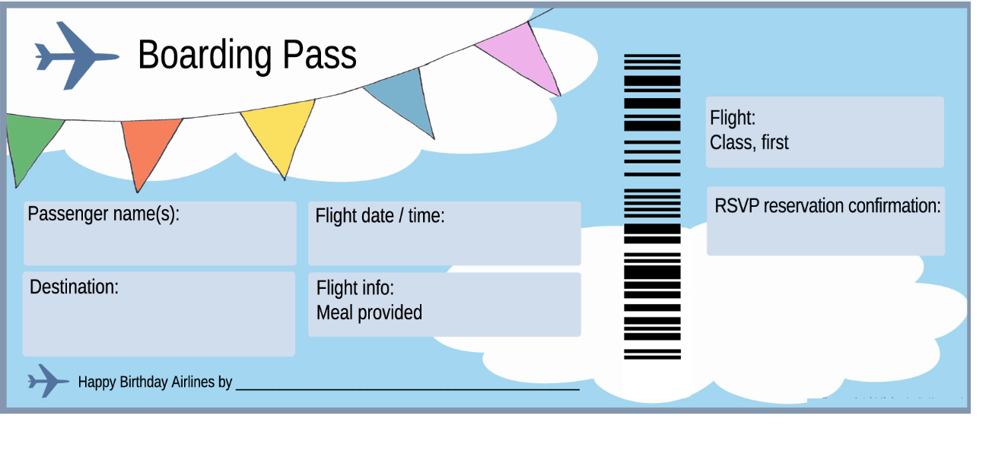
April 10th, 2018
Canada
Canada
April 10th, 2018
April 10th, 2018
Canada
________________________________________________________________________________________________________________________________________
___________________
___________________________________________________________________________________________________________________________________________________________________________________________________________________________________________________________________________________________________________________________________________________________________________________________________ ___________________

___________________
___________________________________________________________________________________________________________________________________________________________________________________________________________________________________________________________________________________________________________________________________________________________________________________________________ ___________________
___________________
___________________________________________________________________________________________________________________________________________________________________________________________________________________________________________________________________________________________________________________________________________________________________________________________________ ___________________
________________________________________________________________________________________________________________________________________

