5th Grade
Puerto Rico

Does Where You Live in the Western Hemisphere determine your happiness?

This fifth grade Inquiry Design Model (IDM) curriculum allows students to explore the happiness of citizens in Puerto Rico and citizens in America through critical analysis of the credibility of primary and secondary documents. Students will investigate these historical resources and undertake the compelling question, “Does Where You Live in the Western Hemisphere Determine Your Happiness?” By completing this IDM, students will not only begin to understand the severity of identifying credible and unreliable information that is presented to them, but how important these issues are pertaining to the world today.

Compelling Question:

Does where you live in the Western Hemisphere determine your happiness?

Staging the Question:

Students will engage in a lesson on It’s Okay to Make Mistakes laying the foundation of the concept of happiness.

Standards and Practices:
5.4 GEOGRAPHY IN THE WESTERN HEMISPHERE: The diverse geography of the Western Hemisphere has influenced human culture and settlement in distinct ways. Human communities in the Western Hemisphere have modified the physical environment.
5.4c The physical environment influences human population distribution, land use, and other forms of economic activity.

5.5 COMPARATIVE CULTURES: The countries of the Western Hemisphere are diverse and the cultures of these countries are rich and varied. Due to their proximity to each other, the countries of the Western Hemisphere share some of the same concerns and issues. (Standards: 1, 2; Themes: ID, MOV, SOC)

5.5a The countries of the Western Hemisphere have varied characteristics and contributions that distinguish them from other countries.

5.5b. Countries in the Western Hemisphere face a variety of concerns and issues specific to the region.

1. Supporting Question:  Does where you live in the hemisphere determine your happiness?  What determines happiness? | Formative Task:  After listening to a book about why it is okay to make mistakes and viewing a PowerPoint about why optimism is the key to happiness, the students will write arguments to support claims using valid reasoning by writing about how they can flip four problems around to see the virtue they can gain from these problems. | Sources:  Source A: It’s Okay to Make Mistakes by Todd Parr  Source B: Google Slides  Source C: Exit Ticket

2. Supporting Question:  Does the geography of Puerto Rico affect the life and happiness of the people living there? | Formative Task:  After taking a virtual bus tour, Students will write a travel journal entry including 3 accurate, relevant reasons why they want to live there. | Sources:  Source A: Bus tour  Source B: Travel Journal Entry  Source C: Google Slides Presentation

3. Supporting Question:  How did Puerto Rico come to be Puerto Rico? What historical events have shaped this state? | Formative Task:  After observing documents and completing the Listen and Retell activity, students will prove their understanding of the documents and how these events have shaped Puerto Rico today through their History Alive Act it Out performance. | Sources:  Source A: Listen and Retell documents  Source B: Exit Ticket  Source C: Google Slides Presentation

4. Supporting Question:  Are the documents showed yesterday valid? | Formative Task:  Use SCIM-C method to answer questions determining the validity of the source. | Sources:  Source A: Google Slides  Source B: Documents  Source C: Exit ticket

5. Supporting Question:  Are Puerto Ricans Happier than Americans? | Formative Task:  After solving a history mystery, students will complete a written task to support their claim on who they believe is happier, Puerto Ricans or Americans. | Sources:  Source A:  History Mystery Envelopes  Source B:  PowerPoint Presentation  Source C:  Supporting Claim Handout

6. Supporting Question:  In what ways is life in Puerto Rico different than life in the United States? Are Americans happier than Puerto Ricans? | Formative Task:  Students will engage in a fishbowl activity to create an essay in the air using the DBQs. | Sources:  Source A: Google slides  Source B: DBQs from previous lessons  Source C: Self-evaluated rubric

Summative Performance Task

Argument : Students will complete an essay in the air answering the questions: In what ways is life in Puerto Rico different than life in the United States? Are Americans happier than Puerto Ricans?
Extension: Students unable to grasp the essay in the air will be given images from the DBQs to create a graphic organizer.

Taking Informed Action  7. Supporting Question:  What is informed action?  How can we help the people living in Puerto Rico who were affected by Hurricane Maria? | Formative Task:  After a video on the devastation caused by Hurricane Maria in Puerto Rico, students will work in small groups to develop plans of informed action that will create real, positive change for the people of Puerto Rico.  Students will work in groups to do one of the following: 1) create an informational video informing people of the tragedy affecting Puerto Rico, 2) create flyers/posters to publicize the needs of the people of Puerto Rico, 3) organize a fundraiser to raise money and supplies for the people of Puerto Rico, 4) create a social media account (facebook, twitter, instagram) publicizing Puerto Rico and the needs of the people that live there. | Sources:  Source A: Action - Definition retrieved from Merriam-Webster.com  Source B: Island of Puerto Rico destroyed by Hurricane Maria - Youtube video  Source C: Informed - Definition retrieved from Merriam-Webster.com

Does Where you live determine your happiness?
GRADE 5 DBQ

Does where you live in the Western Hemisphere shape
your life? Is life in some places happier than others?

Student Name_____________________
Date______________________________

Part III: This part consists of a document-based question. On this part,you will be provided with one version of the test based on your readiness to handle critical thinking challenges. (You may opt for a more difficult version than your teacher provides, but you will be graded on the version that you complete.

Document Based Question

Directions: The task below is based on documents 1 through 6. The task is designed to test your ability to work with documents. Examine each document and answer all questions beneath the document. Use the answers to the questions to help write your essay.

Background: The Western Hemisphere can be divided into regions. Regions within the Western Hemisphere include North America, Mesoamerica, The Caribbean, and South America. These regions may differ based on landscape, geographical features, climate, food, recreational activities, monuments, style of homes, and could have rural urban or suburban spaces within them. All of the differences between the four regions of the Western Hemisphere may or may not affect the happiness of the people living within those regions.

Task: Use the information from the documents and your knowledge of social studies, write an essay in which you:
Use the information from the documents and your knowledge of social studies, write an essay in which you:

- Discuss two factors that psychologists believe make people happy.
- Discuss life in Mexico compared to life in America.
- Evaluate whether the region where you live in this hemisphere determines your happiness.

In your essay remember to
- Write an opinion essay, arguing whether people live a happier life in Mexico or America
- Include an introduction, a body, and a conclusion
- Use information from at least four documents in your answer
- Include historical facts, relevant details, and reason in developing your ideas

Document #1

Optimism and Resilience: Optimism leads to Persistence

Psychologists have long been interested in optimism and we have a good understanding of what it is and why it matters. There have been hundreds of studies of optimism and what we find is that people who think optimistically report fewer symptoms of depression, do better in school and in sports, are more productive at work, and are physically healthier than people who think pessimistically.

How does optimistic thinking lead to all of these good outcomes? We know that optimism is a necessary ingredient of resilience. Research shows that part of what enables people to thrive, despite setback, failure, and hardship, is the ability to think optimistically in the face of adversity. Optimistic thinking motivates people - adults and children - to continue to persist and to work to find solutions, even when situations look bleak. Optimism shines light where it is dark. Optimistic thinkers ask themselves, "Where do I have control? What can I do to make this situation better? What can I learn from this struggle?" Because optimistic thinkers focus on control, they don't slip into helplessness. And because they persist, they tend to succeed.

Excerpt from an Article by Dr. Karen Reivich, Fishful Thinking

1. According to the document, what are three benefits of people who think optimistically?
_____________________________________________________________________________________________________________________________________________________________________________________________________________________________________________________________________________________________________________________[1]

2. According to the document, how does optimism enable people to thrive despite failure and hardship?

_____________________________________________________________________________________________________________________________________________________________________________________________________________________________________________________________________________________________________________________[2]

Document #2

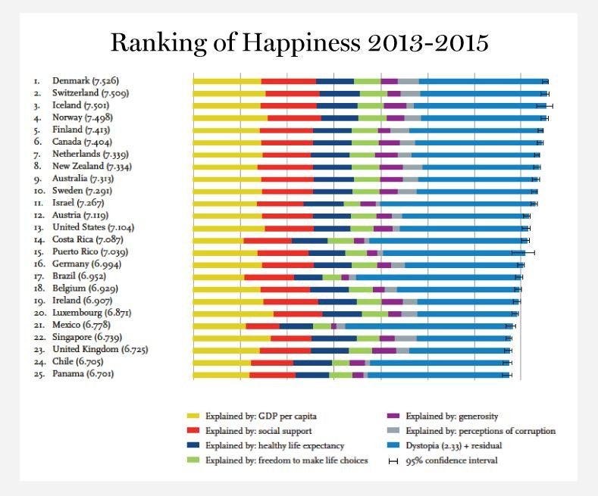
“We are a small island, and people are nice to each other. Everybody gets along. When we pass in the street, we say hello to each other.”
Quotation from Enrique Rodriguez, a retired government worker

1. Where does Puerto Rico rank in world happiness in 2013-2015? ___________[1]

2. According to this ranking, what are three factors that determine happiness?
________________________________________________________________________________________________________________________________________________________________________________________________________________[1]

3. According to Enrique Rodriguez, how do people in Puerto Rico socially support one another? How does this create happiness?
________________________________________________________________________________________________________________________________________________________________________________________________________________[2]

Document #3

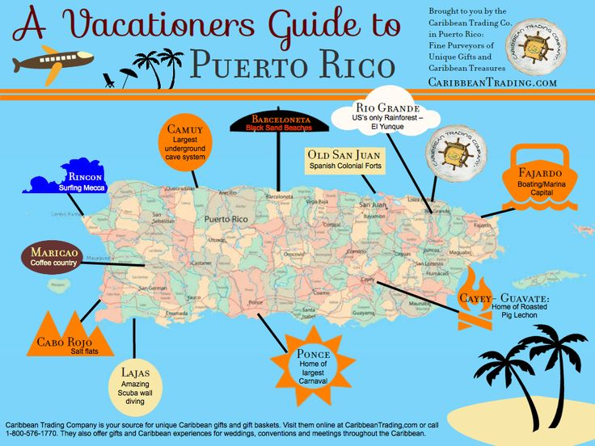

- List 3 activities to do in Puerto Rico
__________________________________
__________________________________
__________________________________[1]

2. How does Puerto Rico’s geography affect the activities to do there?
_________________________________________________________________________________________________________________________________________________________[1]

3. Do these activities affect the people of Puerto Rico’s happiness.
____________________________________________________________________________________________________________________________________________________________
___________________________________________________________________________[2]

Document #4

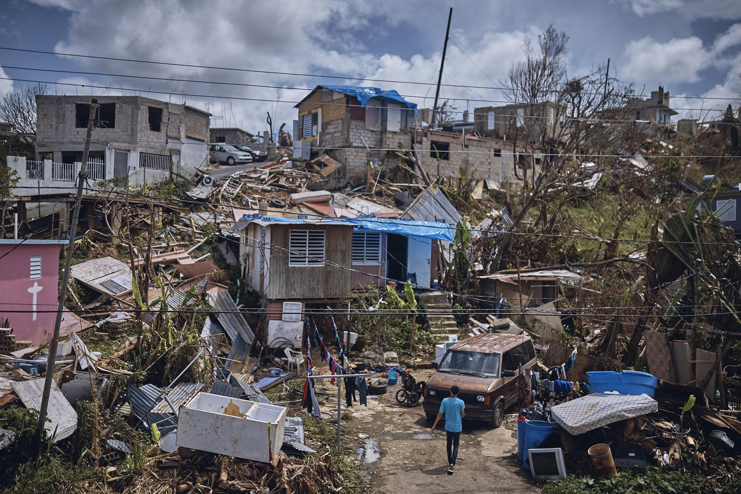
Hurricane Maria (Puerto Rico)

- According to the picture above, do you think the devastation caused in Puerto Rico by Hurricane Maria affected the people’s happiness that live there?

______________________________________________________________________
____________________________________________________________________[1]

2. How do you think you can you help the people in Puerto Rico who were affected by
Hurricane Maria?

______________________________________________________________________
___________________________________________________________________[2]

Document #5

“Puerto Rico ranks number one, as the most blissed-out place in the world, followed by Mexico and Denmark. That's according to a study of over 80 countries by the non-profit group, World Values Survey Association. They ranked the countries based on the answers to various question about happiness from both men and women--Questions like:
- How important are family and friends in your life?
- Looking at every aspect of your life, how happy are you?
- No matter what your parent's faults are, do you agree that they should be loved and respected?
- And do you think most people can be trusted?”

- According to the document how many countries were included in this study?
_______________________________________________________________[1]
2. Referencing the document, how were the countries ranked to determine their happiness?
_________________________________________________________________________________________________________________________________________________________[2]

Document #6:
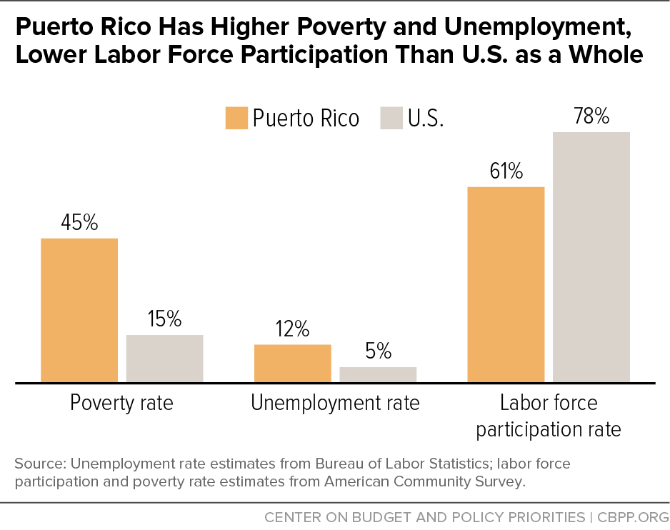

1. What is the percentage of poverty rate, unemployment rate, and labor force participation rate of Puerto Rico compared to the United States?

______________________________________________________________________
____________________________________________________________________[1]

2. Do you think poverty, unemployment, and labor force participation contributes to people’s happiness?

______________________________________________________________________
____________________________________________________________________[2]

Task: Use the information from the documents:

Directions: The task below is based on documents 1 through 5. The task is designed to test your ability to work with documents. Examine each document and answer all questions beneath the document. Use the answers to the questions to help write your essay.

Background: The Western Hemisphere can be divided into regions. Regions within the Western Hemisphere include North America, Mesoamerica, The Caribbean, and South America. These regions may differ based on landscape, geographical features, climate, food, recreational activities, monuments, style of homes, and could have rural urban or suburban spaces within them. All of the differences between the four regions of the Western Hemisphere may or may not affect the happiness of the people living within those regions.

