Molloy College
Division of Education

Student: Anthony Antonacci
Dr. Kevin Sheehan
Course: EDU 3160
Date: 12/2/19
Grade: 12 Topic: U.S. Presidents Content Area: Social Studies

INSTRUCTIONAL OBJECTIVES (s) (Lesson Objective(s)*)
After debating on what character strengths make a good president, students will do read and retells of U.S. President John F. Kennedy, Abraham Lincoln, and Richard Nixon. Students will then work in groups and do a chart in which they connect those presidents with a specific character trait displayed on the chart.

New York State Social Studies Standards

Key Idea:

12.G1 FOUNDATIONS of AMERICAN DEMOCRACY: The principles of American democracy are reflected in the Constitution and the Bill of Rights and in the organization and actions of federal, state, and local government entities. The interpretation and application of American democratic principles continue to evolve and be debated.
Indicator: This will be evident when students do a “presidential characteristics” chart, in which they match a short paragraph about a certain president to a character trait.

Common Core ELA Standards

Key Idea:

WHST1: Write arguments focused on discipline-specific content.

Key Concept:
WHST1a: Introduce precise, knowledgeable claim(s), establish the significance of the claim(s), distinguish the claim(s) from alternate or opposing claims, and create an organization that logically sequences the claim(s), counterclaims, reasons, and evidence
Indicator:
This will be evident when students argue what character traits/strengths make an effective president.

INQUIRY ARC STANDARD: Dimension 1:
Dimension 1 of the arc features developing questions and the planning of investigations. With a robust question in mind, teachers and students determine the kind of content they need to create a plan to address their questions.

Indicator: This will be evident when students do the read and retell of presidential character strengths.

SOCIAL STUDIES SKILLS STANDARD: Gathering, Interpreting and Using Evidence:
2. Recognize and effectively select different forms of evidence used to make meaning in social studies (including primary and secondary sources such as art and photographs, artifacts, oral histories, maps, and graphs).
4. Identify arguments of others.

Indicator: This will be evident when students determine whether or not they would vote for a president based on character.

DEVELOPMENTAL PROCEDURES
(including Key Questions)
- Motivation: Students will talk about character strengths of people they know (this could be another student in the class, family member, etc.)
- AIM: “What character traits/strengths determine a good president?
- Students will do a “think pair-share” on which character traits determine a good president, and circle which traits they choose based on the “character strengths” sheet.
- Students, with their partner, will participate and tell which traits determine a good president in their opinion.
- Read and retell on Lincoln, J.F.K., and Richard Nixon handed out
- Students complete the read and retell with a partner
- Students will participate and give out what they wrote down for the read and retells
- Teacher will hand out the “Presidential character traits” chart.
- Students, if they choose to do so, will work with a partner to connect the quotation about a president with a character trait on the chart, and write in a few sentences, why they matched the president with the trait.
- Students will give their detailed responses from the chart.
- Debate: “based on what you learned, would you elect a president based on character traits?”
- Students will do an exit slip on what the most interesting thing they learned during the lesson was.

ASSESSMENT (artifacts* and assessment [formal & informal]*)
Informal: Teacher will monitor groups of students while they are talking and working together to do the read and retell, and to find out which character trait is related to which president
Teacher will monitor class to make sure they understand the lesson as it progresses.

Formal: Students will identify the character traits of the presidents in the presidential characteristics chart.

INSTRUCTIONAL STRATEGIES (Learning Strategies*)
Read and Retell: Students will do a read and retell on Lincoln, JFK, and Nixon.
Groups: students will work in groups to figure out which character trait is connected to which president
Debate: groups will debate whether they would elect a president or not based on character traits

INDEPENDENT PRACTICE
At home, will write a short paragraph on whether they would elect a president based on the character traits they learned about that certain presidents had.

References

American Government. “Presidential Character.” Retrieved from
https://www.ushistory.org/gov/7e.asp (Information for the character strengths sheet retrieved from this)

Character Strengths sheet
According to .ushistory.org, some common leadership qualities that good Presidents appear to have are the following:
- A strong vision for the country's future
- An ability to put their own times in the perspective of history
- Effective communication skills
- The courage to make unpopular decisions
- Crisis management skills
- Character and integrity
- Wise appointments
- An ability to work with Congress

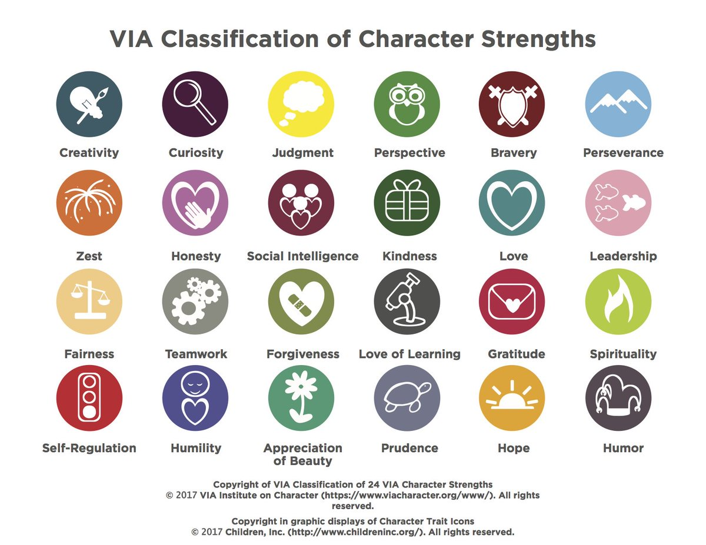

Name Date

Presidential Character Traits
Read and retell (read twice, and please do one paragraph at a time).
Instructor will read paragraphs, write down key words in lines below, with a partner, you will read the paragraph again, they will guess your key words. Writing key words will help you summarize the paragraph you are reading.

John F. Kennedy possessed a great deal of charisma. He was extremely ambitious and was willing to take risks to get what he wanted. This included ambitious goals such as landing on the moon, preventing nuclear war during the Cuban Missile Crisis, and boosting the economy. Kennedy was an outgoing and charming man who used his natural charisma to advance his political career. He was an excellent public speaker who focused on establishing an emotional connection with his audience and speaking positively at all times. His charisma often led him to believe that the normal rules didn't apply to him. Sometimes this confidence took him too far, as he would have affairs with other women despite being married.

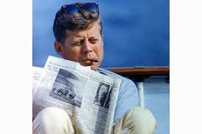

1. ­­________________________

2. __________________________
3. __________________________
4. ___________________________
5. _________________________
A known introvert, Richard Nixon liked to be alone. He rarely used the Oval Office, preferring his hideaway office, from time to time, he would write inspirational notes to himself, about the need for “joy in the job,” and “confidence. Nixon liked to play the role of a tough guy, and was a highly intelligent individual, believing in hard work and dedication. Himself an intellectual who read widely and deeply in political philosophy, who could be truly original in his thinking and who was drawn to intellectuals as advisers. Indeed Nixon practiced what he preached about hard work, attending Whittier College and Duke University, involved in student government for both, he became an attorney after college. After serving the Navy in World War II, he became a congressman, then a senator for California. Nixon then became Eisenhower's vice president, aiding him in many of his policies, running for president against Kennedy (but losing) in 1960, he did not give up, running again in 1968, and winning. Nixon continued his hard work in the White House, like ending the Vietnam war, creating the EPA and other environmental regulations, and opening relations with China after 20 years of hostilities. Nixon’s intelligence sometimes made him overconfident, believing he could get away with anything. As a result, his presidency came to an end in the watergate scandal, where he was accused of sending men to break into DNC offices. Overall, Nixon's hard work and dedication guided him in his life and presidency.

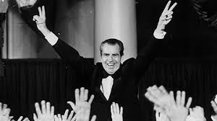

1. ­­________________________

2. __________________________
3. __________________________
4. ___________________________
5. _________________________

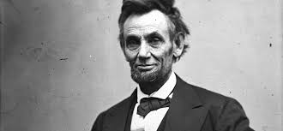

Commonly known as Honest Abe, Abraham Lincoln was a decent, kind, sensitive, compassionate, honest and empathetic. The former president has also been called guarded, patient, energetic and easy going, according to The Lincoln Institute. The man was considered simple, pure and sincere by many. A great, humble leader, Lincoln led the nation during the Civil War and accomplished abolishing slavery with the Emancipation Proclamation in 1863. Lincoln believed that all men were equal under the law and equally deserving of peace and happiness. Lincoln believed in all this, and set to achieve these goals despite dealing with a divided nation. President Obama said he would look up to Lincoln during his campaign, stating he was a “strong character, with leadership and honesty.”

1. ­­________________________

2. __________________________
3. __________________________
4. ___________________________
5. _________________________

Name: Date:
PRESIDENTIAL CHARACTER TRAITS CHART
Directions: On the chart below, you will have descriptions about the presidents we learned below. The presidents are not named, but rather numbered by their description, in the boxes; there are different character traits, (communication, perseverance, charisma, and intelligence.) Write which president you believe the description applies to, and then match that president/description with the character trait you believe best fits him. Under the character trait, explain why you chose that character trait for that specific president. You may apply for a president to more than one trait; just briefly explain why you did so.

Presidential Characteristics graph
 | Communication | Perseverance | Charisma | Intelligence
1. This president never lost sight of the necessity of keeping the United States as one nation, even when it was splitting apart. Always keeping strong character and honesty.

2. This president had an effective speaking voice, and a talent for expressing what he wished to accomplish. |  |  | .
3. This president, despite problems in presidency, had much intelligence and hard work that he used to move a nation forward.  4. This president had a good way of connecting with the American people through his speeches and actions. |  |  | .
 | .
 | .

Presidential Characteristics Essay
Name: Date:

Directions: In a short paragraph, explain why you would, or why you wouldn’t vote for a president based on the characteristics you learned about in class. You may use the read and retell to help write your paragraph.

