Molloy College
Division of Education

Student Carly Spadafora & Christopher Weber Professor K. Sheehan
Course EDU 316 Date 11/29/2018
Grade 7 Topic Hope & Grit in the American Revolution Content Area Social Studies

INSTRUCTIONAL OBJECTIVES (s) (Lesson Objective(s)*)

After being divided into four groups and learning about the influence of hope and grit through events of the American Revolution, students will determine the meaning of words, phrases, figurative language, academic,and content-specific words and analyze their effect by engaging in a read and retell activity with their group members. They will then report their findings on an exit ticket, scoring a four out of six on a teacher constructed rubric.

NYS STANDARDS AND INDICATORS
(you may need more than one standard, all content areas need a content area standard as well as an ELA standard)

Key Idea
7.3 AMERICAN INDEPENDENCE: Growing tensions over political power and economic issues sparked a movement for independence from Great Britain. New York played a critical role in the course and outcome of the American Revolution. (Standards: 1, 4, 5; Themes: TCC, GOV, ECO)
Indicator: This will be evident when students examine documents about Valley Forge,
the Declaration of Independence and the Battle of Saratoga

Key Concepts
7.3c Influenced by Enlightenment ideas and their rights as Englishmen, American colonial leaders outlined their grievances against British policies and actions in the Declaration of Independence.
Indicator: This will be evident when students learn and discuss the signing and creation
of the Declaration of Independence
7.3d The outcome of the American Revolution was influenced by military strategies, geographic considerations, the involvement of the Haudenosaunee (Iroquois) and other Native American groups in the war, and aid from other nations. The Treaty of Paris (1783) established the terms of peace
Indicator: This will be evident when students learn and discuss about conditions at Valley
Forge and the significance of the victory in the Battle of Saratoga

National Social Studies Standards and Themes
V. Individuals, Groups, & Institutions Social studies programs should include experiences that provide for the study of interactions among individuals, groups, and institutions, so that the learner can:
e. identify and describe examples of tensions between an individual’s beliefs and
government policies and laws;
Indicator: This will be evident when students learn about tensions between beliefs of Americans and the policies enforced by Britain during the American Revolution when they learn about the signing of the Declaration of Independence.

IX. Global Connections Social studies programs should include experiences that provide for the study of global connections and independence, so that the learner can:
b. give examples of conflict, cooperation, and interdependence among individuals,
groups,and nations;
Indicator: This will be evident when students discuss examples of conflict among
America and Britain during the Revolution, specifically in studying the Battle of Saratoga

NCSS C3 Inquiry Arc
Dimension 3: Students will work toward conclusions about societal issues, trends, and events by collecting evidence and evaluating its usefulness in developing causal explanations.
Indicator: This will be evident when students analyze the given documents to determine the importance of their event to the American revolution
Dimension 4: Students will draw on knowledge and skills to work individually and collaboratively to conclude their investigations into societal issues, trends, and events and will present their information, portions and findings.
Indicator: This will be evident when students work collaboratively and individually to present why this event was vital to American success during the revolution

Common Core ELA Standards
Key Ideas and Details
1. Read closely to determine what the text says explicitly and to make logical inferences from it, and cite specific textual evidence when writing or speaking to support conclusions drawn from the text.
Indicator: This will be evident when students engage in Read and Retell activity to determine what text says and make logical inferences so they can support conclusions about the event they are studying in their exit ticket.

Social Studies Practices: Habits of Mind
A. Gathering, Interpreting, and using Evidence
1. Develop questions to help identify evidence about topics related to the historical events occurring in the Western Hemisphere that can be answered by gathering, interpreting, and using evidence.
Indicator: This will be evident when the students gather evidence from documents
to engage in read and retell activity and study events of the American Revolution

INSTRUCTIONAL RESOURCES

- Powerpoint Slides on the Battle of Saratoga, Conditions on Valley Forge, and Signing of the Declaration and Read and Retell Activity.
- See-Think-Wonder Worksheet
- Read and Retell Worksheets
  - A - Battle of Saratoga
  - B - Conditions at Valley Forge
  - C - Declaration of Independence
  - D - Give me Liberty or Give me Death
- Exit Ticket - “Pick one event. How did hope and grit of the American people during this event lead to success in the revolution?”

MOTIVATION (Engaging the learner(s)*)

Students will do a See-Think-Wonder after observing the quote “Give me Liberty or Give me Death.” The class will discuss how this quote exemplifies the traits of hope and grit during the American Revolution.

DEVELOPMENTAL PROCEDURES
(including Key Questions)

- Students will be divided into four group by the teachers. (What major event are you studying?)

- Student will be given documents that give them historical background to learn what happened at one specific event. One group will receive a document about the Battle of Saratoga, one group will receive document about the Declaration, the third group will get Valley Forge, and the last group will receive a generic document revolving around hope and grit. (At first glance, what background knowledge do you have about the event you are studying today?

- Teachers will briefly discuss and demonstrate how to complete Read & Retell Activity (How does read & retell work?)

- Students will engage in a “Read & Retell” with a partner to answer questions about the historical background of their document (What do I need to be thinking about as my partner reads the second time? What are five key words you can use to remember the story you are telling?)

- Students will discuss their event in groups to determine important factors. (What are the major details of the event you are reading? What is the significance of your event to the success of the American Revolution? Do you see evidence of hope and grit in your event?)

- Students will complete an exit ticket explaining what they learned about their event (Why is the event you studied important to the success of the American revolution? Were hope and grit key factors behind the specific event you studied today?)

INSTRUCTIONAL STRATEGIES (Learning Strategies*)
Collaboration
Indicator: This will be evident when students work together as they discuss their document
Discussion
Indicator: This will be evident when class engages in discussion during See-Think-Wonder
Guided Questioning
Indicator: This will be evident when the teacher asks questions to keep students thinking as they are completing the document based questions
Independent Practice
Indicator: This will be evident when the students take the information they have learned and independently construct their exit ticket

ADAPTATIONS (Exceptionality*)

N/A

DIFFERENTIATION OF INSTRUCTION

Auditory Learners will benefit from class discussion and “Read and Retell” activity

Visual Learners will benefit from See-Think-Wonder activity and images used alongside documents

Kinesthetic Learners will benefit from engaging in the “Read and Retell” activity with a partner

ASSESSMENT (artifacts* and assessment [formal & informal]*)

Students will complete an exit ticket answering the question “Pick one event. How did hope and grit of the American people during this event lead to success in the revolution?” scoring a minimum of 2 out of 2 on a teacher constructed rubric. Teacher will assess student homework from the night before. Teacher will assess how accurately students completed in-class “Read and Retell” .

INDEPENDENT PRACTICE

Students will construct 2-3 sentences describing an event in their life when they felt they displayed the characteristics of hope and grit.

FOLLOW-UP ACTIVITIES: DIRECT TEACHER INTERVENTION AND ACADEMIC ENRICHMENT

Direct Teacher Intervention
For students who are struggling during document analysis, teacher will assist directly.

Academic Enrichment
N/A

REFERENCES

Britannica, T. E. (2018, September 25). Valley Forge. Retrieved from
https://www.britannica.com/place/Valley-Forge-historical-area
New York State K-8 Social Studies Framework. (n.d.). Retrieved from
https://www.engageny.org/resource/new-york-state-k-12-social-studies-framework
New York State P-12 Common Core Learning Standards for English Language Arts & Literacy.
(n.d.). Retrieved from ​https://www.engageny.org/resource/new-york-state-p-12-
common-​core-learning-standards-for-english-language-arts-and-literacy
Patrick Henry's 'Give Me Liberty, or Give Me Death!' Speech. (2018, March 29). Retrieved from
https://www.theobjectivestandard.com/2018/03/patrick-henrys-give-liberty-give-death-speech/
Saratoga: The Tide Turns on the Frontier--Reading 3. (n.d.). Retrieved from
https://www.nps.gov/nr/twhp/wwwlps/lessons/93saratoga/93facts3.htm
The Declaration of Independence: Full text. (n.d.). Retrieved from
http://www.ushistory.org/declaration/document/

Name:__________________________________ Date:___________________
Document #1: The Declaration of Independence
“And for the support of this Declaration, with a firm reliance on the protection of Divine Providence (God), we mutually pledge to each other our Lives, our Fortunes, and our sacred Honor.”
- The Declaration of Independence, 1776

Some men felt so strongly about creating a new form of government and declaring independence from the British that they were willing to give their possessions, lives and legacies to fight for it. Independence was so important that they drafted a declaration of their independence from the British crown. These men met at the Continental Congress of Philadelphia in 1776, to read the words written by Thomas Jefferson, outlining their ideas for the new nation they hoped to create. The messages in this document included a chance for the American people to govern themselves and be independent members of this new country. They hoped to give a chance to the people, by the people and for the people. These men of the Continental Congress proudly signed their names on the bottom of this parchment to signify their rebellion from British monarchy. One signature especially stood out, John Hancock of Massachusetts, who wanted his statement to be bold and clear. These men knew that their signatures could mean their death, however, they so firmly believed in their cause that they were willing to take this risk. | 1.  2.  3.  4.  5.
Name:__________________________________ Date:___________________
Document #2: The Battle of Saratoga
“I believe it was the severest Battle ever fought in America...The Enemy’s loss must have been very great by sustaining an American Fire for at least 4 Hours. The ground...was thickly scattered with their dead Bodies and I nothing doubt at the lowest compilation we killed took and wounded 1,500 of the enemy.”
- Lt. Col. Alexander Scammell of the 3rd New Hampshire Regiment in a letter to his brother

According to Lt. Col. Alexander Scammell, this was the most dangerous battle that the American patriots ever fought. By June of the year 1777, nearly 8,000 British soldiers were marching their way down from Canada with the intent to end the American Revolution. These men were led by General John Burgoyne, one of the most distinguished officers in the British army. This army had an abundance of supplies traveling with them on their journey, including 200 wagons of military supplies. The American soldiers were severely outnumbers and had to resort to unconventional warfare tactics. They used the strategy of guerilla warfare, which was a series of surprise attacks and ambushes. Considering that the British troops were only trained for open battlefield combat, this gave Americans an advantage. This battle was months of bullets flying and every soldier on the brink of death. As a result, it was a very bloody and hard-fought battle, leaving American troops victorious as they killed, captured and wounded a great deal of British soldiers and cornered General Burgoyne into a surrender. | 1.  2.  3.  4.  5.

Name:__________________________________ Date:___________________
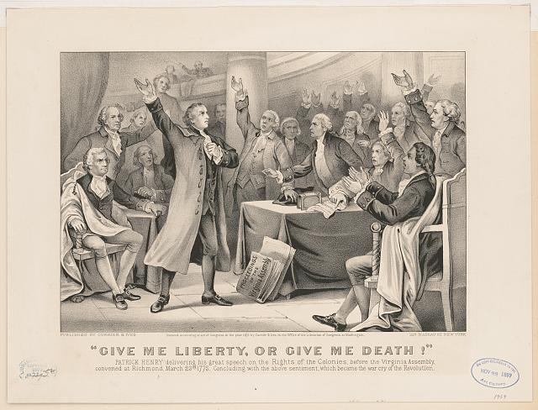
Document #3: “Give me Liberty or Give me Death!”

At the second Virginia Convention of 1775, the balance hangs in the air as representatives of Virginia decided whether or not to support the American Revolution at hand. Patrick Henry, a young attorney, stands in front of the convention to deliver a speech in full support of passing the resolution to send Virginian troops. He stands confidently asking members for their support exclaiming proudly “Give me Liberty or Give me Death!” Ultimately, he was stating that he was willing to die for his freedom. An air of silence falls over the room moments after. This speech is ultimately what swings the vote in favor of support. Henry even spoke to minds such as Thomas Jefferson and George Washington on this day. According to Thomas Marshall, it was “one of the most bold, vehement, and animated pieces of eloquence that had ever been delivered.” | 1.  2.  3.  4.  5.

Name:__________________________________ Date:___________________
Document #4: Conditions at Valley Forge
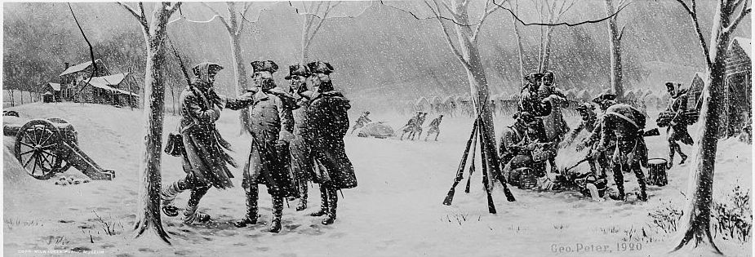

Valley Forge, Pennsylvania was one of the several encampments used by the American patriots during the revolution. General George Washington, leading commander, kept troops focused and motivated during some of the worst conditions. It was a brutal winter at Valley Forge. There were no provisions or reinforcement sent for the men there. Most men had no clothing or shoes, so when they would walk, a trail of bloody footprints was left behind them. They quickly ran out of meat, and resorted to either eating their own horses or a mixture of water and flour known as firecakes. Illness was rampant among the men, and they were specifically subject to a disease known as smallpox. This disease spread like wildfire and had little immunity to it. General Washington practiced “inoculation” or a form of vaccination in which he spread the disease to healthy members of the army in hopes that they would develop an immunity. Luckily, Washington’s very risky plan works, and the death rate by smallpox drops dramatically. Overall, the Americans had to exhibit extreme fortitude and discipline to survive these hard conditions at Valley Forge. | 1.  2.  3.  4.  5.
Name:__________________________________ Date:___________________

SEE | THINK | WONDER
Name:__________________________________ Date:___________________
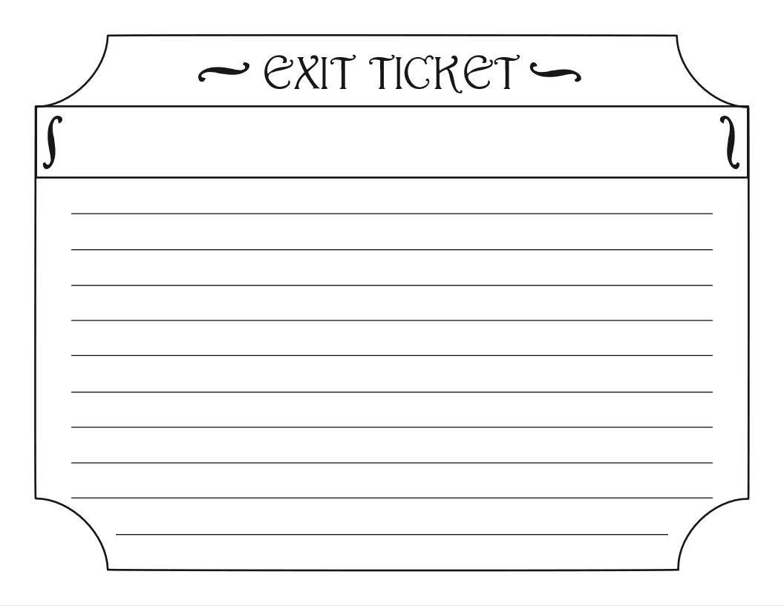
Name:__________________________________ Date:___________________

HOMEWORK
Write 3-5 sentences about a time in your life when you demonstrated characteristics of hope and grit.

______________________________________________________________

______________________________________________________________

______________________________________________________________

______________________________________________________________

______________________________________________________________

______________________________________________________________

______________________________________________________________

______________________________________________________________

______________________________________________________________

______________________________________________________________

______________________________________________________________

______________________________________________________________

______________________________________________________________

______________________________________________________________

______________________________________________________________

