Molloy College
Division of Education

Belen Walston & Melissa Torre Dr. Sheehan
EDU 0509-01 04/12/2019
Grade 4: History Mystery: Industrial Revolution Content Area: Social Studies
INSTRUCTIONAL OBJECTIVE
After analyzing documents from primary and secondary sources, students will write arguments to support claims in an analysis of substantive topics or texts by gathering evidence to make an informed decision from the documents presented in a history mystery and determine if the Industrial Revolution was fueled by a growth mindset. Groups will present their finding to the class using at least three solid arguments to support their decision.
NYS-CCLS / +NYS STANDARDS AND INDICATORS
New York State Social Studies Standards
Key Idea:4.6 WESTWARD MOVEMENT AND INDUSTRIALIZATION: New York State played an important role in the growth of the United States. During the 1800s, people traveled west looking for opportunities. Economic activities in New York State are varied and have changed over time, with improvements in transportation and technology. (Standards: 1, 3, 4; Themes: MOV, TCC, GEO, ECO, TECH)
Key concept:4.6e Entrepreneurs and inventors associated with New York State have made important contributions to business and technology.

Indicator: This will be evident when students use their thinking like a historian skills to analyze the growth

National Social Studies Standards and Themes
VI. Science and Technology
This will be evident when students analyze the clues to see how the Inventors and Entrepreneurs of the Industrial Revolution create and change structures of power authority and governance.
c. describes instances in which changes in values, beliefs, and attitudes have resulted from new scientific and technological knowledge, such as conservation of resources and awareness of chemicals harmful to live and the environment;
Individual Development & Identity:Social studies programs should include experiences that provide for the study of individual development and identity, so that the learner can:
e.identifies and describe ways family, groups, and community influence the individual’s daily life and personal choices
Indicator: This will be evident when students analyze the clues to see how the inventors and entrepreneurs of the industrial revolution create and change structures of power, authority, and governace.
NCSS C3 Inquiry
Dimension 3: Students will work toward conclusions about societal issues, trends, and events by collecting evidence and evaluating its usefulness in developing causal explanations.
Indicator: This will be evident when students evaluate the usefulness of evidence in the
history mystery to answer the compelling question.
Common Core ELA Standards
Integration of Knowledge and Ideas
7. Delineate and evaluate the argument and specific claims in a text, including the validity of the reasoning and the relevance and sufficiency of the evidence.
Indicator: This will be evident when students including the validity of the reasoning and the relevance and sufficiency of the evidence in the history mystery.
Text Types and Purposes
1. Write arguments to support claims in an analysis of substantive topics or texts, using valid reasoning and relevant and sufficient evidence.
Indicator: This will be evident when students write and support a claim, using valid reasoning and relevant and sufficient evidence from the history mystery.
Social Studies Practices: Habits of Mind
A. Gathering, Interpreting, and using Evidence
2. Recognize and effectively select different forms of evidence used to make meaning in social studies (including primary and secondary sources such as art and photographs, artifacts, oral histories, maps, and graphs).
Indicator: This will be evident when students recognize and effectively select credible evidence in the history mystery to write arguments to support their claims.
INSTRUCTIONAL RESOURCES
● SMART board
● History Mystery PowerPoint
- The case of the broken case https://youtu.be/m-zgsuwshIU (Youtube video)
● 4 history mystery envelopes ( 1 for each group)
● Poster paper
● Tape
- ChromeBook
● Supporting claims handout (Case Files)
- Group Job responsibility worksheet
- Document credibility cheat sheet
● Document findings worksheet
● Exit Ticket

MOTIVATION
Students will be shown a video “The case of the broken vase”( https://youtu.be/m-zgsuwshIU) about a child detective trying to solve a mystery for his mother, after the video students will asked to solve their own a mystery here in class. Their assignment will be to solve the mystery of “Was the Industrial Revolution Fueled by Grit ?”
DEVELOPMENTAL PROCEDURES
- Students will be shown a the Youtube video The case of the broken vase about a child detective solving a mystery. This will serve as a motivational tool for the students to introduce the History Mystery assignment. (How did the child use clues to help him form a decision? How would you feel about being a detective?
- The teacher will discuss the rules of the lesson with the students and break down the class into groups of four. (Why are rules important? Are there any rules you think needed to be added to the guidelines before we begin?)
- Once in their groups, students will be assigned a job responsibility while working in their groups; distributor, organizer, leader or communicator.
- Students will then participate in a history mystery where they will analyze and discuss context clues to determine if they believe the Industrial Revolution was fueled by a growth mindset. (Is there any bias in this evidence? What clue sticks out most to you and why? Do you think these clues can help you form a solid argument to help support your decision?)
- In groups, students will order the evidence from least to most credible on a provided graphic organizer. (Is there evidence that is more credible than others? How do you determine credibility of evidence?)
- After fifteen minutes, groups will share with the class their findings from the history mystery assignment and share their opinions on whether or not the Industrial Revolution was fueled by a growth mindset. (What conclusion did your group come up with? Which pieces of evidence did you use to come to this conclusion? What clues did you think were the strongest? Which clues did you think were the weakest?)
- To close the lesson, the students will complete an exit ticket on their Chromebooks on the Industrial Revolution, in which they discuss their favorite part of the lesson, what they learned, and how they personal feel about the context clues they used during the lesson.
INSTRUCTIONAL STRATEGIES
Mystery Strategy: using the idea of becoming detectives and solving a mystery as students formulate ideas and clues.

Indicator: This will be evident when students act as detectives and provide sound evidence to solve the History Mystery question.
Collaboration: Students will work together in groups to research, analyze, and synthesize context clues to help answer the History Mystery question.
Indicator: This will be evident when students are put into groups to share ideas about the history mystery and work together to come to a conclusion.
Discussion: engaging in meaningful discussions about the content

Indicator: This will be evident when students present their findings and conclusions to the class based on the evidence examined.

DIFFERENTIATION OF INSTRUCTION
Visual Learners
For visual learners, students will be able to visually view the photos provided as evidence within the history mystery.
Kinesthetic
For kinesthetic learners, students will be able to physically place the documents from most credible to least credible on poster paper.
Linguistic
For linguistic learners, students will be able to read the documents given, verbalize why they feel it is credible or non-credible, and write arguments to support their claim.
Auditory
For auditory learners, students will be able to listen to their peers during the class discussion before, during and after the history mystery activity.
ASSESSMENT
● The teacher will assess student interactions during group work.
● The teacher will monitor and evaluate students’ presentation of their findings from the history mystery based on their use of at least three solid arguments to support their decision.
● The teacher will assess student knowledge and understanding of the topic based on class discussion before, during and after the history mystery.
INDEPENDENT PRACTICE
Students will be asked to complete an exit ticket on their ChromeBooks addressing what is a growth mindset. The students will answer the history mystery question, Was The Industrial Revolution Fueled by a Growth Mindset. The exit ticket will also ask students what was their favorite part of the lesson, and something interesting they learned while being detectives.

FOLLOW-UP ACTIVITIES: DIRECT TEACHER INTERVENTION AND ACADEMIC ENRICHMENT
Direct Teacher Intervention
For struggling students, the teacher will review how to determine whether the document is credible or non-credible. The teacher will then provide them with a cheat sheet that will break down the criteria on what makes a document reliable or not. The sheet will be a guide for students to use when examining evidence in a source they may be unsure of. The students will then be able to read the evidence and analyze documents in order to answer the compelling question.
Academic Enrichment
In order to further the lesson, for the students who excelled during the lesson, will be challenged to find two sources to add to our mystery. They will have to find a document that can be used as evidence to further support their findings from the mystery. Students will need to determine if the evidence is credible enough to be used as valid evidence to support their findings.

History Mystery Context Clues
Document #1
I Regard my people as I regard my Machinery. So long as they do my work for what I choose to pay them, I keep them, getting out of them all I can. What they do or how they fare outside of my walls, I don’t know, nor do I consider it my business to know. They must look out for themselves as I do for myself.
Source: Massachusetts Bureau of labor, 13th Annual Report, 1883.
Business owner Massachusetts

Document #2
“But we had no trust or monopolies than. I paid my own bills, and always had a little something to give away, and the happiness of saving some. in fact, I am not so independent now as I was then. It is true I could not secure the most fashionable cut clothing. I remember I bought mine then of a cheap clothier. He told me clothing cheap, clothing such as I could pay for, and it was a great deal better than buying clothing that I could not pay for. I did not make any obligations I could not meet. I live within my means, and my advice to you young men, is to do just the same”.

John D. Rockefeller-Personal journal entry.
Document #3
“Honey, it isn’t democracy that runs this country. Capitalism rules. It does no good to reason with the capitalists or their politicians. This is a class war. We have to stir up the American people, the lower class. Some of the better-off lower class do show some sympathy for us when they’re smacked with the facts. And when they voice themselves collectively, good things happen.” — Mother Jones”
― Jerry Ash
Document # 4
“ The Industrial Revolution and its consequences have been a disaster for the human race. They have greatly increased the life-expectancy of those of us who live in “advanced” countries, but they have destabilized society, have made life unfulfilling, have subjected human beings to indignities, have led to widespread psychological suffering (in the Third World to physical suffering as well) and have inflicted severe damage on the natural world. The continued development of technology will worsen the situation. It will certainly subject human beings to greater indignities and inflict greater damage on the natural world, it will probably lead to greater social disruption and psychological suffering, and it may lead to increased physical suffering even in “advanced” countries.”
-Theodore John Kaczynski, Industrial Society and Its Future

Document #5
“Our greatest weakness lies in giving up. The most certain way to succeed is always to try just one more time.”
-Thomas Edison

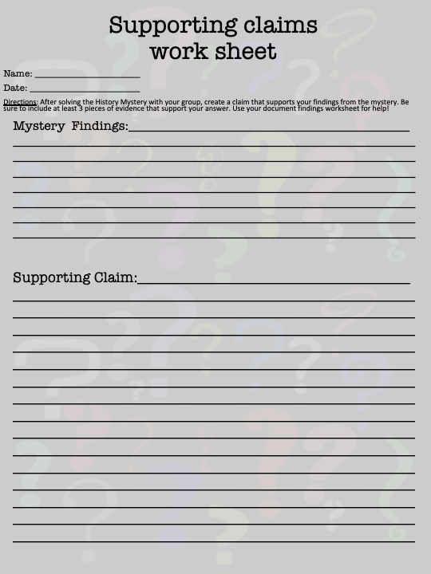
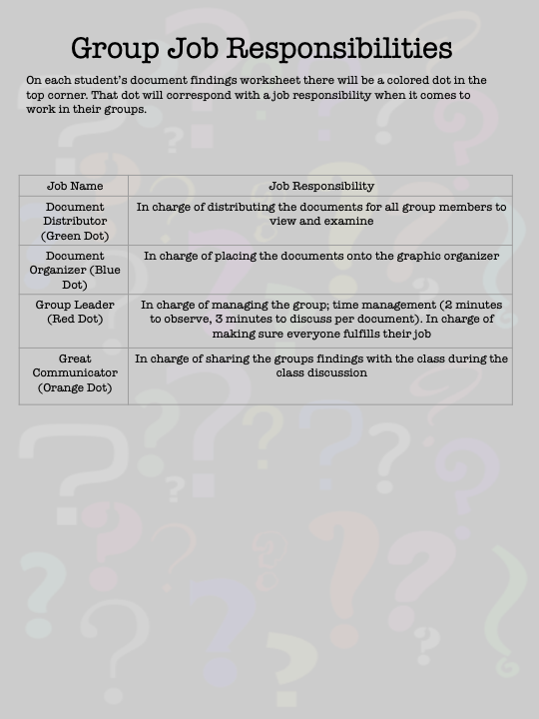
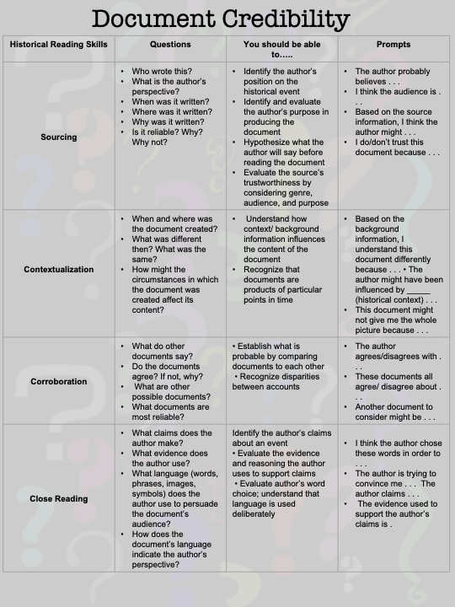
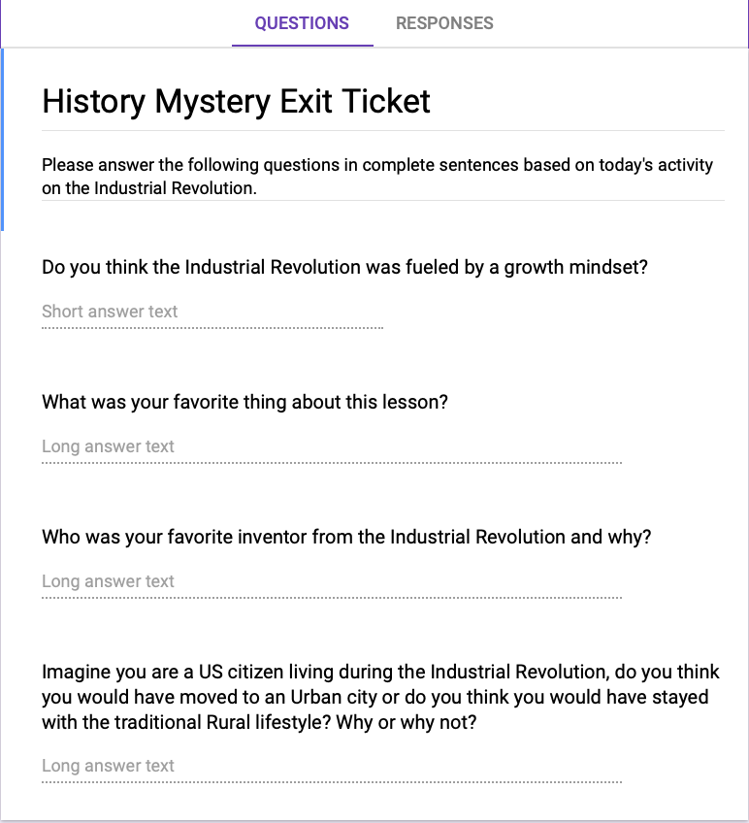

REFERENCES

EvanTubeHD. (2016, April 24). The CASE of the BROKEN VASE! An EvanTubeHD Detective Story. Retrieved April 16, 2019, from https://www.youtube.com/watch?v=m-zgsuwshIU

Historical Thinking Chart. (n.d.). Retrieved April 16, 2019, from https://sheg.stanford.edu/history-lessons/historical-thinking-chart

U. (1852). Executive documents printed by order of the Senate of the United States during the first session of the thirty-second Congress, 1851-52 (14th ed., Vol. 2, Ser. 16). Washington: Printed by A. Boyd Hamilton. doi:april 28,2019

In Their Own Words. (n.d.). Retrieved April 30, 2019, from https://rockarch.org/inownwords/firstledgertext.php

Ash, J. (2019, May 4). Re: Industrial revolution quote [Online forum comment]. Retrieved from https://www.goodreads.com/quotes/869401-honey-it-isn-t-democracy- that- runs-this-country-capitalism-rules

Kaczynski,T. (2018). Industrial society and its future. New York, NY: Pub House Books.

Thomas A. Edison Quotes. (n.d.). Retrieved April 30, 2019, from https://www.brainyquote.com/quotes/thomas_a_edison_149049

