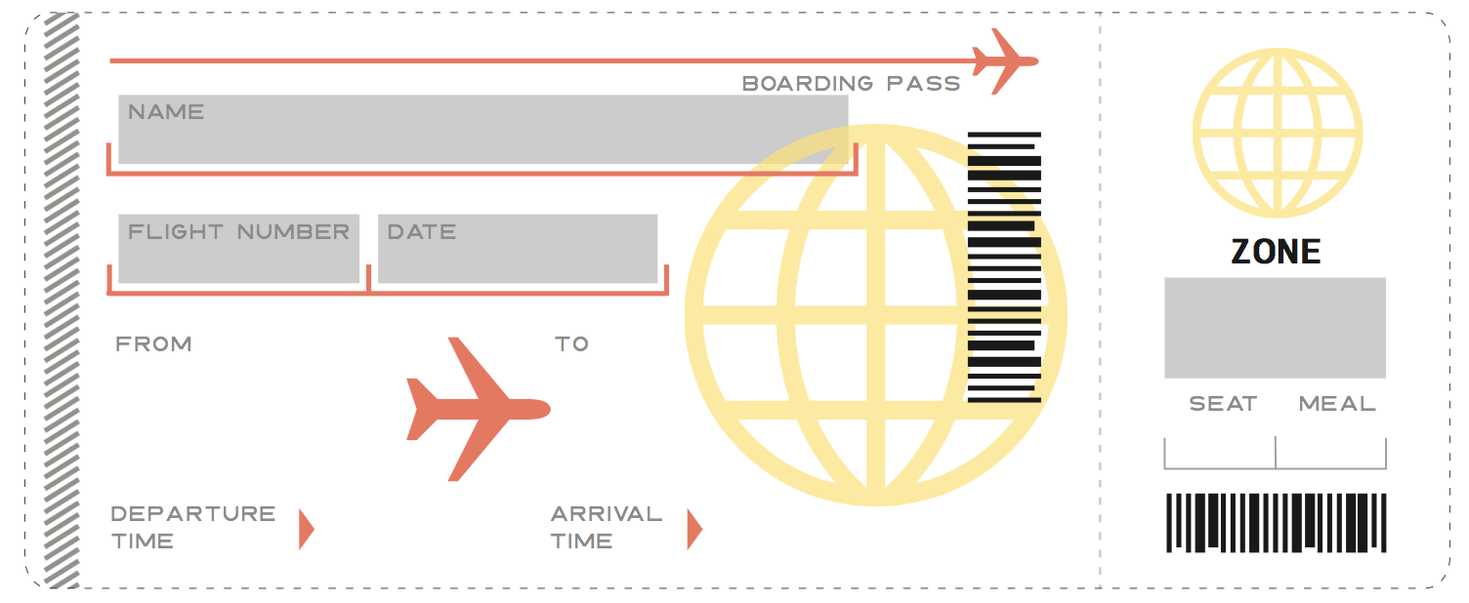

**Happiness Airlines**



**14B**

**Happiness Airlines**

**April 5, 2018**

**1604**

**SJU**

**JFK**

**1:36**

**9:48**

**1**

**1**

**14A**

**1:36**

**SJU**

**9:48**

**JFK**

**April 5, 2018**

**1604**

**9:48**

**1:36**

**SJU**

**JFK**

**1604**

**14A**

**1**

**April 5, 2018**

**Happiness Airlines**